SQUASH WALES
Protocol for Elite Athletes to Resume Training

VALID AS OF 22nd JUNE 2020

Introduction

This document is designed to outline the safeguarding measures and guidance Squash Wales has deemed appropriate to allow its elite athletes to return to training (Phase 1). All Squash Wales guidance will be updated as per Welsh Government guidelines when they are made available or as soon as possible thereafter.
These guidelines will apply to Wales only, in line with Welsh Government’s Sport, Recreation and Leisure: Guidance for a phased return document.
In phase 1, facilities users will be limited to elite/world class athletes as set out in the Welsh Government Unlocking our Society and Economy: Continuing the conversation document. There will be an agreed standard method of operation for all staff and users to follow.
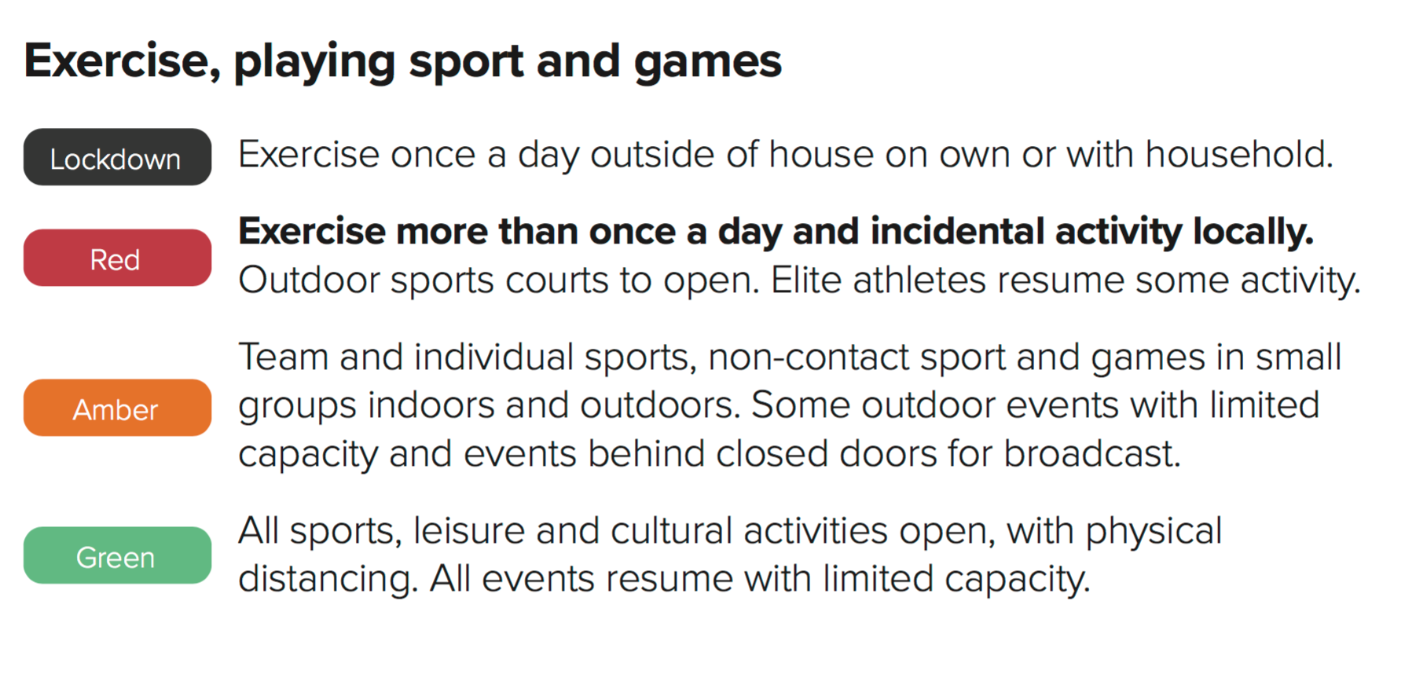
Welsh Government Unlocking our Society and Economy: Continuing the conversation (May 2020)

Elite

By definition, elite refers to individuals who are nominated by their national governing body, but only those governing bodies who nominate for Olympic, Paralympic or Commonwealth Games for representation by Great Britain or Wales (Welsh Government’s Sport, Recreation and Leisure: Guidance for a phased return document).
All athletes will be over the age of 16.

COVID-19

Any athlete, coach or member of staff experiencing/displaying any COVID-19 symptoms, must not attend any training sites and must self-isolate for a minimum of 7 days even if symptoms are mild in line with Public Health guidelines and inform Squash Wales Performance Director (David Evans) or COVID-19 Medical officer Dr Rhodri Martin. Those that live in the same household with someone who has symptoms consistent with COVID-19 must self-isolate for a minimum of 14 days (or 7 days after they develop any symptoms).

Symptoms
As per the Public Health Guidelines, athletes, coaches and support staff should not leave home if they or someone they live with experiences any of the following symptoms:
A high temperature
A new, continuous cough
A loss of, or change to, sense of smell or taste.

Return to Training after COVID-19
Athletes who have experienced even mild symptoms, have experienced prolonged fatigue and/or shortness of breath should be guided through a phased return to training as advised by the current Home Countries Institutes guidance. They must be encouraged not to hurry their return and reassured that a slow recovery is very common.

Accountable Officers
COVID-19 Officer: Richard Bennett (Vice Chair Squash Wales)
r.bennett@bangor.ac.uk

COVID-19 Medical Officer: Dr Rhodri Martin (Sport Wales)
rhodri.martin@sport.wales
Familiar with the emerging evidence related to post COVID-19 pathology and lead on ensuring any suspected or confirmed COVID-19 cases are managed in line with the Home Countries Institute’s COVID-19 case management protocols and current government guidance; have medical oversight of the return to training of any athletes with suspected or confirmed cases of COVID-19; and Support the COVID-19 Officer with any medical aspects of the risk assessment and mitigation process.

COVID-19 Warden: Beenish Kamal (Sport Wales)
Beenish.kamal@sport.wales

Assist both the COVID-19 Officer and COVID-19 Medical officer in risk assessment and mitigation, facilitating processes, undertake training site screening for symptoms as set out in the return to training guidance.

Site Specific COVID-19 Officer: To be named by each facility
Responsible for oversight of the venue’s COVID-19 risk assessment and mitigation plan, ensuring the necessary level of risk assessment and mitigation has taken place and that sports and hosts can

BEFORE, DURING & AFTER YOUR BOOKED TRAINING SESSION

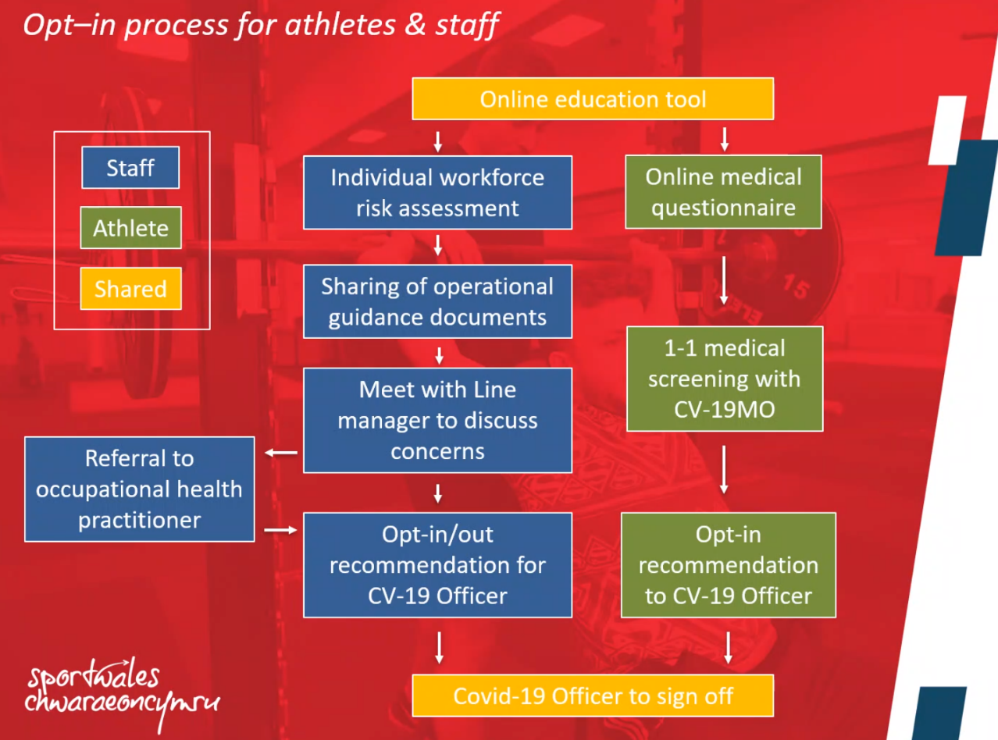
Should a return to elite training be permissible ahead of a general relaxation in the public health guidelines, all users (athletes, coaches, staff) will be required to undertake a formal process of education to fully inform them of any risk and identify circumstances where individuals may wish to opt-out of a return in phase 1. The Sport Wales flow diagram below outlines the processes involved for each user (coaches included as part of the blue staff group).

Prior to returning to training, athletes, coaches and staff must complete.
- A virtual medical screening questionnaire (1:1) check in prior to resumption of organised training
- An opt-in disclaimer form

Athletes/coaches/Squash Wales staff will not be forced to return to training and will be provided with the opportunity to train if they wish.

Athletes/coaches and staff should be aware that they are able to ‘opt out’ of any organised training environments at any time without any prejudice.

The 1:1 check in prior to the resumption of official training will ensure athletes and coaches understand the sport specific risks and mitigations, training site protocols in place, are physically and mentally well enough to engage in return to training and have actively ‘opted in’ to engaging in Phase 1 return to training.

** Coaches please consider your athletes current physical and psychosocial state when planning specific training sessions, please take into consideration their current training level given the lockdown restrictions, their readiness to return to training (physical and psychological) and the lack of support services available in phase.

Coaching and training decisions should be made to minimise the injury and illness risk/NHS burden as a priority consideration.

No face to face manual therapy/physiotherapy will be available in phase 1. This will look to be implemented within referral criteria and strict hygiene regulations in phase 2.

Control Measures prior to entering the building
Keep up to date - please make sure you are up to date with any recent updates in Welsh Government, Public Health Wales or Squash Wales advice and guidance.

- Each Player and staff member must sign a Squash Wales opt in to resume training disclaimer form and have undergone a thorough procedural presentation regarding rules, education of risks and standards expected.
- Prior to each session every athlete/coach must complete their COVID-19 screening questions by 9am of the morning of their session. This will be reviewed by Squash Wales COVID-19 Medical Officer.
- Anyone with issues or displaying symptoms must not attend the SWNC and inform the COVID-19 – 19 Officer.
- All players and staff must travel individually to the centre unless they are living in the same household.
- Daily temperatures will be checked using a non-contact forehead thermometer. A temperature of 37.8 degrees Celsius or over will result in non-admittance to the venue.
- Daily register of players/staff attending the session to be taken and stored on Squash Wales SharePoint
Failure to complete any of the above will result in refusal of entry to the venue

Control Measures when inside the building

- All players and staff must make their way directly to the squash court seating where staff will direct each player to their own individual space on the spectator seating area. Spaces will be allocated for each training session.
- There will be no access to changing rooms throughout the training session. Toilet facilities will be allocated prior to each session by the Duty Manager (these might vary from session to session).
- Players and staff will bring in own food and drinks as no catering facilities will be available.
- 2m Social Distancing ruling must always be adhered to.
- Players and staff are not to walk around the building at any time. When not on court they are to remain in the squash court seating area.

Emergency Evacuation Procedure

- If the Fire Alarm is activated, players and staff members must make their way to the nearest fire exit and to the front of the building Muster station. Once outside the Fire marshal will ask if all players and staff are accounted for. Everyone is to remain outside until Sport Wales staff inform that they can return to the centre.

HYGEINE REGULATIONS ON COURT

Disinfectant Gel

- Hand sanitisers to be available outside every courts as well as disinfectant wipes/ spray with paper towel for players to wipe ball, racket.
- Players to sanitise their hands before and after playing before touching any surface.

Cleaning

- Strengthen cleaning cycles after each use.
- Courts to be cleaned on a regular basis. As a minimum there should be a daily deep clean of the courts.

Communication on the Rules

Display instructions at the entrance to the courts on the importance of compliance with current hygiene measures.

- No hands on, no hugs, kisses, handshakes.
- Do not wipe hands on walls or rear glass back wall.
- The use of a mask on court is mandatory.
- Everyone must bring their own equipment.
- Handling of the same ball by different players during a session should be prevented.
- Use your own water bottle and do not share it. No use of water fountains.
- Disinfectant is present at the rear of all courts for the handles.
- The handles are disinfected by the customer by spraying the product and wiping it with a paper towel.
- Each athlete to have their designated area behind the court.
- Athletes to turn up to training already in their playing kit.
- Athletes to bring adequate towels that will need to be placed in a black bag (bin liner) then taken home to be washed.
- Athletes to take small supplies to treat minor injuries and to take a phone in case of emergency.

RULES WHEN PLAYING

Key Rules for the Game

What’s Allowed

- Solo training.
- Training with coaches is allowed but must respect the rules of social distancing.
- Training with another member but must respect the rules of social distancing.

What is NOT Allowed

- Matches remain banned.
- No more than two players at a time on the court.

The resumption of squash, solo or through conditioned games in one against one allows a practice fully respectful of the Welsh Government health guidelines.

GAME FORM AND EXERCISES

POST COVID – 19 ROUTINES THE 2 METRE GAMES

Below are some ideas for routines when you are allowed back on court that adhere to the social distancing guidelines

- Boast & Straight Drive

- Straight Drop & Straight Drive – FH/BH

- Straight Drop & Straight Lob – FH/BH

- Straight Drop & Cross-Court Lob – FH/BH

- Straight Drop & Cross-Court Drive – FH/BH

- Boast & Cross-Court Drive – FH/BH

- Boast & Cross-Court Lob – FH/BH

- Sides, Front Quarter – FH/BH

- Sides, ¾ length (back of service box) – FH/BH

- Sides, Whole Court Length – FH/BH

- Boast, Straight Drive, then Boast & Cross-Court Drive

- Boast & Cross-Court Lob, Boast & Straight Lob

- Back player Straight Drive, then Straight Long Drop. Front player Straight Drop, then Cross-Court Lob

- Back player Straight Drive, then Boast. Front player Straight Drop, then Cross-Court Lob

- Back player plays any short ball, front player returns to same corner

- Back player plays any short ball, front player returns to either back corner

- Back player hits Straight Drops, front player returns to any back corner

- Back player hits any short shot, front player can only hit to back with Straight Drives

- Back player hits any short shot, front player can only hit Cross-Court Drives to the back

- Front player can hit any shot to the back. Back player can only play a Boast

Control Measures when session has ended
- All players and staff to sanitise hands after playing
- Door handles to be sanitised with wipes provided
- All wet kit/equipment to be placed inside personal kit bag
- All players and staff to wait for Duty Manager to escort them directly out of the building. No shower facilities available

