SQUASH WALES
Protocol for the re-opening of Squash Clubs

VALID AS OF 20th JUNE 2020

CONTENTS

- Introduction
- Welsh Government Road Map
- Squash Wales Traffic Light System
- Pre-Phase One
- Access and Organisation of Clubs.
- Hygiene Regulations on court.
- Rules when on court.
- Game Form and Exercises.
- Legal Guidance.

INTRODUCTION

The purpose of this document is to provide Squash Wales overarching plan for the implementation and management of procedures supporting its affiliated clubs, club members and squash participants in the staged resumption of squash activities in Wales.
The recommendations are not intended to replace the opinion of a medical professional but to assist the clubs in the various actions to be adopted when the possible re opening of Squash Clubs in Wales is allowed.
It is important to ensure that an organisational plan is in place before squash courts are re-opened. Clear, precise rules and procedures will be essential to ensure a safe resumption of the Sport along with excellent communication to encourage the members to return to the clubs when the opportunity arises.
Particular attention will be made to reassure players that their safety is paramount and that strict regulations will be put in place to ensure this.
At all times, the Plan is subject to all regulations, guidelines and directions of government and public health authorities, and the operations and directions of privately or community-owned facilities.
KEY PRINCIPLES
The Plan also accepts as key principles that:
- The health and safety of members, participants, coaches, officials, administrators/volunteers, visitors, families and the broader community is the number one priority.
- Members, participants, coaches, officials, administrators/volunteers, families and the broader community need to be engaged and briefed on the return to sport plans.
- Facilities are assessed and appropriate plans are developed to accommodate upgraded hygiene protocols, physical distancing and other measures to mitigate the risk of transmission of COVID-19.
- Training cannot resume until the arrangements for sport operations and facility operations are finalised and approved.
- At every stage of the return to sport process Squash Wales must consider, recommend and apply where able to all applicable Welsh Government restrictions and regulations. Squash Wales needs to be prepared for any localised outbreak.

Current Welsh Regulations

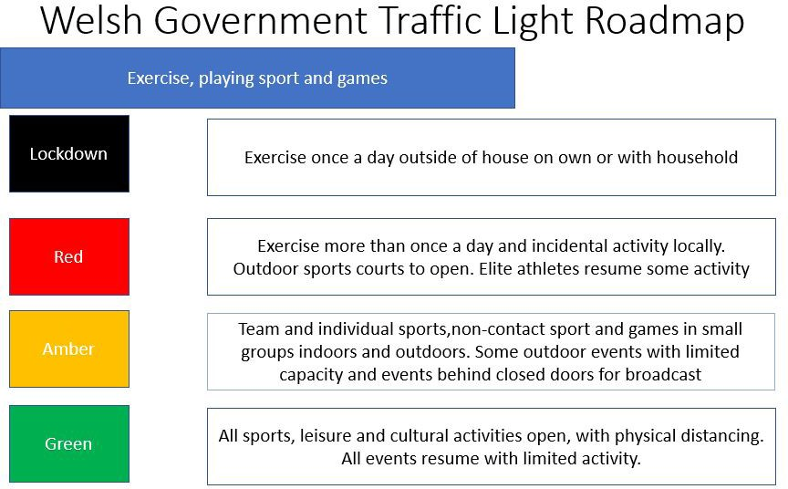

The Traffic light phases for seeing family and friends and for getting around are also of particular relevance to decision making

Squash Wales traffic light
Element of the Sport | Lockdown | Red | Amber | Green
Training | Solo training, or with family members, at home or within walking distance of home. One exercise session per day. | Solo training, or with a family member at home or within 5 miles of your home. No limit on the amount of sessions per day | Training resumes at all facilities with risk management measures in place at all venues with reduced numbers adhering to the social distancing restrictions. | Training resumes at all facilities with risk management measures in place at all venues.
Clubs | Face to Face Club activity cancelled, clubs maintain remote engagement with members.  Solo training, or with family members, at home or within walking distance of home. | Face to Face Club activity cancelled, clubs should maintain remote engagement with members.  Clubs to plan for a potential return to facility use and engage with Squash Wales , facility operators/providers where appropriate | Indoor Facilities to re-open with venue specific guidelines and protocols in place. Easing of Travel restrictions.  Clubs to work with Squash Wales, facility providers to develop a safe Return to Use Plan at the dedicated Squash facilities. Play restricted to observe distancing regulations in place (unless from the same household). One to one coaching with distancing restrictions. | Indoor facilities re-open with venue specific guidelines and protocols in place.  Face to face club nights resume - restricted by Government guidelines on numbers of players gathering at one time and distancing measures in place.  All formats of playing, training and competition resumed at all venues in line with PHW & Government guidance.
Coaching | All face to face activity suspended. Online/via correspondence training only. Webinar to communicate with all stakeholders. | All face to face activity suspended. Online/via correspondence training only. Webinar to communicate with all stakeholders. | Coaching resumes at all facilities with risk management measures in place at all venues adhering to the social distancing restrictions. | Coaching resumes at all facilities with risk management measures in place at all venues.
Tournament Competition | All activity suspended | All activity suspended | All activity suspended | Tournament competition resumes at all facilities with risk management measures in place at all venues.
League Competition | All activity suspended | All activity suspended | All activity suspended | League competition resumes at all facilities with risk management measures in place at all venues
Coach Education | All activity suspended | All activity suspended | Face to face courses resume with limited capacity and social distancing in place. Online courses to be held. | Face to face courses resume with limited capacity and social distancing in place.
Running the sport – Governance structures & staff working | Online meetings & home working | Online meetings & home working. | Reduced office working & face to face meetings to resume with social distancing in place. | Office working & face to face meetings to resume with social distancing in place.

PRE-PHASE ONE – RE OPENING OF CLUBS

- Ensure a plan is in place before reopening of squash courts. There will be pressure from members to restart as soon as possible, but clear policies and procedures are essential to ensure a safe restart of squash.
- Ensure communications go out well in advance to members to encourage them back, to re-assure them that safety is paramount and the regulations that will be in place.
- Appoint a Covid – 19 contact to lead the planning of a safe reopening of your squash courts and oversee an action plan.
- Prepare resources to assist with the education of members based on their individual responsibilities to help prevent further spread of Covid – 19.
- Ensure appropriate posters highlighting the rules are positioned at all entry & exit points.
- Agree how you will deal with players who break the strict policies in place. Players who break the rules should have their membership suspended/terminated.
- Consider the moving of all court booking processes online. This will also act as a log of who has been in the club and aid contact tracing as required.
- A sign–in sign–out system should be introduced so there is a complete log of who was at the courts or in the club at any one time. This will assist with tracing should a member contract Covid – 19.
- Travel to facilities to be encouraged to be by foot, bike or car (only shared with person from same household).
- Hand sanitiser to be put outside every court and at entrance to and exit from the club.

ACCESS AND ORGANISATION OF THE CLUB
Ensuring physical distancing – Customer Management.
Club managers must ensure that the physical distance of at least 2 metres between two people is respected. Compliance with this rule means an individual area of 4 square metres per person will determine the maximum attendance threshold for the club.
Club managers are obviously free to set a lower threshold that considers, among other things the layout of the premises (sanitary facilities, traffic plan etc) and the safety of the club’s environment.
Club managers must ensure that the maximum attendance threshold for their club is met.
- Court time must be booked in advance. Remote booking will limit the influx beyond the permitted allowance. Only arrive a maximum of 15 mins before the time.
- Members to arrive 15 minutes before court booking. 15-minute delay between bookings will allow time to disinfect chairs, handles, doors and rear glass back wall.
- Introduce a sign in system to the club. This will help find players who might have been in contact with someone with the virus.
- Consider parking arrangements, if applicable, to help members social distance on arrival at the club.
- Designate a waiting area away from the courts for members with 2m distance between each person and a maximum allowed at any one time, to wait if there are already the maximum number of people at the courts.
- Determine the maximum number of players allowed in the club/ squash area at any one time.
- At least one identifiable member of the organisation is responsible for the entry and exit phases. Block admissions once the attendance limit has been reached.
- Ensure there is a sink with soap and/or hand sanitiser close to the entrance of the club. All players to clean hands thoroughly on arrival and leaving.
Home and ground marking
- The direction of traffic is marked clearly on the ground. Particular attention is paid to the flow of people so that they do not cross paths. They are organised with enough space to avoid crossings
- The minimum space of 2 metres between people is clearly marked on the ground in the reception areas and all waiting areas in and outside the club.
- If necessary, install a protective window at the front desk to protect staff. Use contactless or online payment.
Recommendation for use of equipment
- All equipment is strictly personal. The member must come with their own racket, ball, water bottle and towel.
- The club will not be able to lend any equipment to its members.
- All bags must be stored carefully.
- Disinfections must be carried out between each use of a locker.
Furniture
- All furniture present at the back of the court or in the players area is to be removed (tables, chairs, sofa etc).
- Water Fountains to be removed.
Health
- Implement a policy of one person in the toilet / changing rooms at any one time. For clarity, the changing rooms should not be operational for showering or changing but as toilets only.
- Toilets should be cleaned hourly. If no staff to clean, then provide hand sanitizer and disinfectant wipes or disinfectant spray and paper towels so players can take their own safety precautions.
- Single paper towel dispensers or airflow driers in the toilets
- Disposal bins should be lined with a plastic bag for easy disposal of rubbish
- If a cleaning team is not employed full time, provide disinfectant wipes or , disinfectant spray and paper towels (preferably the latter as more environmentally friendly) outside each court for all players to wipe down touch surfaces, such as the door handle, after play.
- Ensure enough no-touch bins available to dispose of the towels / wipes
- Hand sanitisers to be available outside every courts as well as disinfectant wipes/ spray with paper towel for players to wipe ball, racket. Players to sanitise their hands after playing before touching any surface.
- All clubs should consider the First Aid available to players. Encourage all members to take small supplies to treat minor injuries and to take a phone in case of emergency.

HYGEINE REGULATIONS ON COURT

Disinfectant Gel

- Hand sanitisers to be available outside every courts as well as disinfectant wipes/ spray with paper towel for players to wipe ball, racket.
- Players to sanitise their hands before and after playing before touching any surface.

Cleaning

- Strengthen cleaning cycles after each use.
- Courts to be cleaned on a regular basis. As a minimum there should be a daily deep clean of the courts.

Communication on the Rules

Display instructions at the entrance to the courts on the importance of compliance with current hygiene measures.

- No hands on, no hugs, kisses, handshakes.
- Do not wipe hands on walls or rear glass back wall.
- The use of a mask on court is not mandatory.
- Everyone must bring their own equipment.
- Handling of the same ball by different players during a session should be prevented.
- Use your own water bottle and do not share it. No use of water fountains.
- Disinfectant is present at the rear of all courts for the handles.
- The handles are disinfected by the customer by spraying the product and wiping it with a paper towel.
- Each athlete to have their designated area behind the court.
- Athletes to turn up to training already in their playing kit.
- Athletes to bring adequate towels that will need to be placed in a black bag (bin liner) then taken home to be washed.

6

RULES WHEN PLAYING

Key Rules for the Game

What’s Allowed

- Solo training.
- Training with coaches is allowed but must respect the rules of social distancing.
- Training with another member but must respect the rules of social distancing.

What is NOT Allowed

- Matches remain banned.
- No more than two players at a time on the court.

The resumption of squash, solo or through conditioned games in one against one allows a practice fully respectful of the Welsh Government health guidelines.

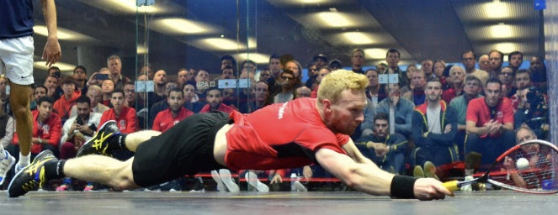

GAME FORM AND EXERCISES

POST COVID – 19 ROUTINES THE 2 METRE GAMES

Below are some ideas for routines when you are allowed back on court that adhere to the social distancing guidelines

- Boast & Straight Drive

- Straight Drop & Straight Drive – FH/BH

- Straight Drop & Straight Lob – FH/BH

- Straight Drop & Cross-Court Lob – FH/BH

- Straight Drop & Cross-Court Drive – FH/BH

- Boast & Cross-Court Drive – FH/BH

- Boast & Cross-Court Lob – FH/BH

- Sides, Front Quarter – FH/BH

- Sides, ¾ length (back of service box) – FH/BH

- Sides, Whole Court Length – FH/BH

- Boast, Straight Drive, then Boast & Cross-Court Drive

- Boast & Cross-Court Lob, Boast & Straight Lob

- Back player Straight Drive, then Straight Long Drop. Front player Straight Drop, then Cross-Court Lob

- Back player Straight Drive, then Boast. Front player Straight Drop, then Cross-Court Lob

- Back player plays any short ball, front player returns to same corner

- Back player plays any short ball, front player returns to either back corner

- Back player hits Straight Drops, front player returns to any back corner

- Back player hits any short shot, front player can only hit to back with Straight Drives

- Back player hits any short shot, front player can only hit Cross-Court Drives to the back

- Front player can hit any shot to the back. Back player can only play a Boast
Some practical thoughts about legal position on return to play

- Welsh Government (WG) is expected to publish return to play guidelines over the coming months.

- Squash Wales (SQW) is working with other NGBs and our partners to secure and ensure a safe return to the playing of squash and racketball.

- Here are some practical thoughts on the legal position upon return to play:

- Local Authorities responsible for Leisure Centres and Private Members’ Clubs need to follow the guidance provided for return to play as varied from time to time.
- In LA leisure centres, it is important that internal “clubs” ensure their players respect and abide by the guidelines.
- In Private Members’ Clubs, that responsibility will rest with the Club itself / its committee and members.
- Local Authorities will be expected to have an appropriate general risk assessment in place for the return to play of squash/racketball and to review this regularly, especially if WG guidance changes.
- In Private Members’ Clubs, it is recommended that Clubs put in place their own general risk assessment which should again be regularly reviewed if WG guidance changes.
- It is to be expected that Local Authorities have appropriate insurance in place.
- It is important that Private Members’ Clubs have such insurance in place, review the extent of cover available and ensure compliance with the policy terms and conditions.
- In Leisure Centres and Private Members’ Clubs, players / members must be supported in and prepared to challenge fellow players who are breaching the guidelines.

- What if a player tests positive for COVID- 19 and claims it was contracted on court? Is there a potential claim?

- Key general points:

- Is the player owed a duty of care by the local authority or private club? Yes*.
- Has that duty been breached? This will be a matter of evidence.
- If yes to b., has the breach CAUSED COVID – 19?
- If yes to c., what is the value of the claim?

*The law is complicated in respect of claims by a member against his or her own club. Independent legal advice should therefore be sought.

- An affected player / potential claimant may be able to establish 5 a. and b. above. However, it will be more difficult to prove a LINK between the playing of squash / racketball on a particular occasion and the contraction of COVID – 19. Without that link, there is no claim.

- In summary therefore, ensure:

- Full compliance with the return to play guidance as varied from time to time.
- An appropriate risk assessment is in place and kept under review.
- Appropriate insurance is in place and there is full compliance with its terms and conditions.
- Players / members are supported in and prepared to challenge any fellow player / member who is seen to be breaching the guidelines.
- Players / members appreciate the potential for a claim arising from the contraction of COVID – 19.

DISCLAIMER:

The above is generic advice from Squash Wales for the benefit of its members, affiliated clubs and County Associations. Squash Wales has taken all reasonable care to ensure the accuracy of the information provided. SW cannot however accept responsibility for any error or omission or for any loss caused or sustained by any reliance on it. Before taking any specific action based on the above, members, clubs and County Associations are advised to check the up to date position and to seek appropriate independent advice.

