CARBON REDUCTION PLAN

Welsh Sports Association

17th Of April 2026
Contents
Introduction and Net Zero Commitment 2
1. Baseline Year Carbon Emissions 4
2. Current Year Carbon Emissions 4
2.1. Summary of Current Carbon Emissions 5
3. Carbon Emissions Reduction 6
3.1. Targets 6
3.2. Projected vs. Actual Reduction 6
3.3. Actions 7
4. Action Plan 8
4.1. Calculating Our Emissions 8
4.2. Energy & Water Efficiency 8
4.3. Logistics 9
4.4. Procurement 9
4.5. Waste Generated in Operations 9
4.6. Biodiversity 10
4.7. Employees 10
4.8. Local Community 10
5. Methodology & Governance 10
6. Declaration & Sign Off 11
7. Appendix 12
7. Appendix 12
7.1. Background of the Carbon Emissions Scopes 12
7.2. Legislative & Policy Context 13
References 14

Introduction and Net Zero Commitment
We aim to achieve Net Zero as an organisation by 2050.
To achieve this ambitious aim, we will make reducing carbon emissions integral to all business planning and decision-making processes.
This Carbon Reduction Plan details the key initiatives we will put in place as our business grows to achieve our Net Zero ambitions.

Baseline Year Carbon Emissions
Baseline year carbon emissions are the reference point against which emission reductions can be measured. They are a record of the greenhouse gases that have been emitted in the past prior to the introduction of any emission reduction strategies.
Baseline Year | 2024
Scope 1 Emissions | 0.0 | tCO₂e
Scope 2 Emissions | 1.4 | tCO₂e
Scope 3 Emissions | 3.49 | tCO₂e
Total Carbon Emissions | 4.89 | tCO₂e

Current Year Carbon Emissions
Current year carbon emissions are a record of the greenhouse gases that have been emitted in the most current reporting year following the introduction of emission reduction strategies.
Current Year | 2025
Scope 1 Emissions | 0.0 | tCO₂e
Scope 2 Emissions | 0.5 | tCO₂e
Scope 3 Emissions | 10.43 | tCO₂e
Total Carbon Emissions | 10.93 | tCO₂e
Scope 3 Categories (inc. WPPN 06/21 Categories):
Waste | 0.12 | tCO₂e
Business Travel | 2.12 | tCO₂e
Employee Commuting | 7.97 | tCO₂e

Summary of Current Carbon Emissions
Emission  Scope | Description |  | End Use |  | Current Year Carbon Emissions (tCO₂e) | % of  Total
Scope 2 | Electricity |  | Energy to power electrical office equipment |  | 0.66 | 6%
Emission  Scope | Scope 3 Category |  |  | Relevant to the Business? | Current Year Carbon Emissions (tCO₂e) | % of  Total
Scope 3 | 1 | Purchased Goods & Services |  | Yes – business purchases office supplies | 0.03 | <1%
Scope 3 | 2 | Capital Goods |  | No – business does not have relevant capital assets
Scope 3 | 3 | Fuel & Energy-Related Activities  Not included in Scope 1 or Scope 2 |  | No – energy use is limited to purchased electricity (scope 2)
Scope 3 | 4 | Upstream  Transportation & Distribution |  | No – data not currently available
Scope 3 | 5 | Waste Generated in Operations |  | Yes – office activity generates some waste | 0.12 | 1%
Scope 3 | 6 | Business Travel |  | Yes – business activity occasionally involves travel | 2.12 | 20%
Scope 3 | 7 | Employee Commuting |  | Yes – staff commute to the office part of the week | 7.97 | 73%
Scope 3 | 9 | Downstream  Transportation & Distribution |  | No – business does not transport/distribute goods

Carbon Emissions Reduction

Targets
In order to be Net Zero, we need to first make significant reductions to our carbon emissions and then offsetting as a last resort. Any offsetting will be used to counteract the essential emissions that remain after all available reduction initiatives have been implemented.
To achieve Net Zero by 2050, we have adopted the following carbon reduction target:
We project that our carbon emissions will decrease over the next five years to 7.72 tCO₂e by 2031
This is a reduction of 29%.

Projected vs. Actual Reduction
Using the Science-Based Targets Initiative¹ recommended 4.2% annual reduction on baseline emissions, the projected Net Zero pathway is shown in the chart below, demonstrating our actual carbon emissions to date against our projected carbon emissions.

Highest Emitting Sources
Rank | Emissions Source | Current Carbon Emissions (tCO₂e) | % of Total | Suggested Actions
1 | Employee Commuting | 7.97 | 73% | -Incentivise Active Transport  -Increase home working  -Encourage public transport or group travel
2 | Business Travel | 2.13 | 20% | -Reduce business travel  -Switch travel mode
3 | Electricity | 0.66 | 6% | -Move to green energy tariff  -Staff behaviour change  -Replace electrical items with low energy options as needed
4 | Waste | 0.12 | 1% | -Reduce use of single use items  -Recycle as much as possible  -Reduce unnecessary waste
5 | Consumed Goods and Services | 0.03 | <1% | -Consider sustainable/local suppliers where possible

Action Plan

Calculating Our Emissions
To manage our emissions, we need to regularly monitor and record our emissions, following the actions below. The Sustainability Champion is responsible for collecting and recording the data as well as publishing the annual emissions report.
Action | Target | Timeframe
Identify a person in the organisation who is responsible for collecting the emission data and for reviewing the progress of these actions. | Sustainability Champion appointed | Completed April 2025
Create a database to easily record and review our emission data. | Database created. | Completed March 2025
Identify, record and calculate our Scope 2 emissions.  (Emissions generated from purchased electricity, steam, heating and cooling consumed by an organisation.) | Emissions itinerary created. | On-going
Identify Scope 3 Emissions².  (All other emissions generated in an organisation’s value chain, especially: Purchased Goods & Services, Employee Commuting, Business Travel and Waste Generated.) | Emissions itinerary created. | On-going
Create plan for assessing how will we start collecting data to calculate Scope 3 emissions. | Scope 3 data collection plan created. | On-going
Create log database for air condition usage. | Collect Scope 1 emissions statistics. | 2026
Conducted a staff commuting survey. | Collect Staff community millage. | Completed 2025
Develop and implement a sustainable travel policy for both business travel which aligns with the sustainable transport hierarchy. For instance, a sustainable travel policy may include:  1) Commitment to the sustainable travel hierarchy for business travel and commuting where possible  2) Details of any benefits or incentives in place (e.g. cycle to work scheme, higher reimbursement rates for preferred methods of business travel)  3) Staff obligations when planning business travel (e.g. an obligation to check all public transport routes, list of 'eco-friendly' hotels to book from or what to look out for when booking a more sustainable hotel).  Ensure the developed policy is effectively communicated with staff. | Sustainable transport policy created | Completed 2025
Via the sustainable travel policy, where active or public transport is not possible, encourage carpooling by encouraging communication between employees and volunteers travelling to the same destination. | Carpool policy created | Completed 2025
Work with Sport Wales registry to identify the supply chain of office equipment the business uses and purchase. | Collect the supply chain of office equipment statistics. | On-going

Energy & Water Efficiency
We will encourage staff to be energy efficient by following these energy saving practices.
Action | Target | Timeframe
Regularly review and improve the energy efficiency of our business. | A continued reduction in electricity/gas consumption. | On-going
Regularly review and reduce the water consumption of our business. | A continued reduction/ no increase in water consumption. | On-going
Encourage staff to be energy efficient by making it part of usual procedure to turn all electrical equipment and lighting when not in use. | 100% staff aware of and engaged in our energy and water efficiency practices. | On-going
Engage with landlords on leased operational buildings, energy efficacy/provider and collect primary data for consumption. | Number of discussions had with landlord regarding type of energy usage and sustainable building procedures. | 2026
When purchasing new office equipment researching and comparing devises to the average UK wattage. | All office equipment under UK average wattage for device | On-going
Staff training initiatives held to communicate to staff how their own behaviour can assist in reducing energy use, both at home and in operational buildings. This could include signposting staff to relevant resources and Government support available to improve their home energy efficiency when working from home. | Number of staff training sessions held  Annual energy consumption | Completed 2025
Create data base and record all water cooler tanks purchased and consumed. | Collect water usage statistics | On-going

Logistics
We will continue to minimise mileage and logistic fuel consumption through the following methods.
Action | Target | Timeframe
Encourage staff to car share, use public transport/ cycle/walk to work. | Increase the number of staff car sharing and/or using public transport/cycling/walking to work. | On-going
Utilise digital technologies for virtual meetings, minimising travel mileage. | Increase the number of virtual meetings. | On-going
Implement a salary sacrifice scheme to encourage uptake of EV cars by staff | Salary sacrifice scheme implemented | Completed 2025
Implement a cycle to work scheme | Salary sacrifice scheme implemented | Completed 2021

Procurement
We will increase the sustainability of our supply chain using the following practices and policies.
Action | Target | Timeframe
Ask new/existing suppliers to provide evidence of their sustainability practices and policies to ensure they match our decarbonisation aspirations. | 100% of our suppliers can evidence their sustainable practices. | Short-term
Encourage re-use principles for items such as furniture, IT equipment, and office supplies, amongst others. | Reuse policy implemented | On-going
Engage with Sports Wales registry to review products materials that is used | Collect product material information | On-going

Waste Generated in Operations
We will focus on reducing the waste generated by the business by implementing the below actions.
Action | Target | Timeframe
Record how much waste is generated and monitor disposal routes, setting annual reduction targets. | Create a waste management plan and set reduction targets. | Short-term
Only order quantities of materials and products that we know we will use to avoid unnecessary waste. | No products/ materials left over after each project. | On-going
Avoid single-use plastic, and reuse and recycle materials/products as much as possible to minimise waste sent to landfill. | XX% reduction in waste sent to landfill. | On-going
Become a paperless business, utilising digital services to reduce the amount of paper we use. | Digitalise the business as much as possible. | Short-term
Avoid using products with excess packaging and wherever possible, make sure packaging is recyclable and/or can be reused. | The amount of packaging that is delivered is reduced by XX%. | On-going

Employees
We do our best to provide our staff with support on matters such as upskilling, mental health and emotional wellbeing.
Action | Target | Timeframe
Provide training opportunities for employees to allow for growth and upskilling. | Increase the number of training courses attended by employees. | On-going
Provide ongoing support to improve our team’s physical health, mental health and well-being. | Ensure 100% of the employees are aware of the support services we provide. | Mid-term

Local Community
We will continue to work with our local community to help where we can.
Action | Target | Timeframe
Partnered with Kate Strong to help deliver the Taff Tidy world record attempt to clean up the river Taff. | World Record for the most people cleaning a river at different points at once. | Completed 2025
Partner with Admiral to deliver the Sustainability in Sport Fund. | Secure £100,000 of funding for the sports sector in Wales. | On-going
Partner with Sustainable minded organisations such as You. Smart. Thing. 2buy2, CalQrisk and Harlequin. | Provide sustainable options and value to the Sports Sector in Wales. | On-going
Deliver yearly Sustainability in Sports conference. | Successful delivery of the annual Sustainability in Sports conference. | On-going
Maintain yearly membership of BASIS. | Collaborate with the sector to develop understanding and enhance sustainable practice standards | On-going

Methodology & Governance
The Sustainability Champion will monitor our progress against the actions set out in this Action Plan and ensure that we meet the targets set within the timeframes.
The Sustainability Champion will review our progress annually and publish the findings in an annual sustainability report. They will also regularly report our progress to the key stakeholders of the business.

Declaration & Sign Off
This Carbon Reduction Plan has been completed in accordance with PPN 06/21 and associated guidance and reporting standard for Carbon Reduction Plans.
Emissions have been reported and recorded in accordance with the published reporting standard for Carbon Reduction Plans and the GHG Reporting Protocol corporate standard and uses the appropriate Government emission conversion factors for greenhouse gas company reporting.
Scope 1 and Scope 2 emissions have been reported in accordance with SECR requirements, and the required subset of Scope 3 emissions have been reported in accordance with the published reporting standard for Carbon Reduction Plans and the Corporate Value Chain (Scope 3) Standard.
This Carbon Reduction Plan has been reviewed and signed off by the board of directors (or equivalent management body).
Name: Andrew Howard
Position: Chief Executive Officer
Date: 17/04/2026
Next Review Date: 01/04/2027

Appendix

Appendix

Background of the Carbon Emissions Scopes
One of the leading organisations offering standards and guidance for the accounting of a business’s carbon emissions is the GHG Protocol. The GHG protocol first categorised the reporting of carbon emissions into 3 Scopes: Scope 1, Scope 2, and Scope 3. The GHG Protocol defines each scope as follows:
- Scope 1: Direct emissions from owned or controlled sources.
- Scope 2: Indirect emissions from the generation of purchased electricity.
- Scope 3: All other indirect emissions that occur in a company’s supply chain.
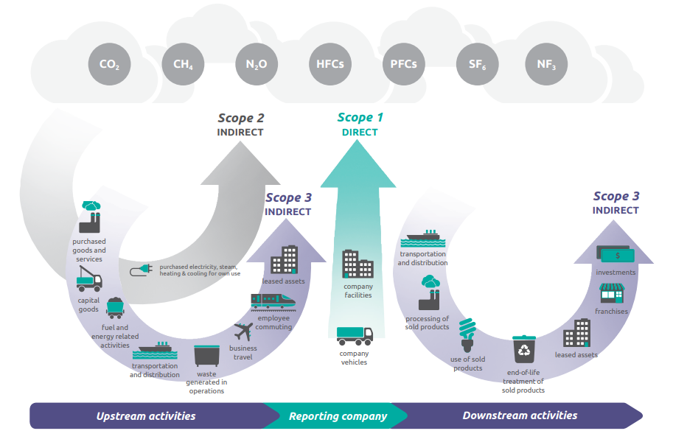 Figure 1: Overview of GHG Protocol Scopes and Emissions³

Legislative & Policy Context
The climate crisis is one of the biggest challenges of our time. Wales declared a climate emergency in 2019 and the Welsh Government has legislated to reduce greenhouse gas (GHG) emissions to net zero by 2050.
This document and the Carbon Reduction Plan supports:
- The 17 UN Sustainability Development Goals (SDG4)⁴, which cover global issues such as poverty, inequality, and climate change and which the private sector is expected to contribute towards.

- The Well-being of Future Generations (Wales) Act (2015)⁵, which provides a framework for sustainable development in Wales and aims to ensure that the needs of the present are met without compromising the ability of future generations to meet their own needs.

- The Environment (Wales) Act 2016⁶, which requires Wales to reduce greenhouse gas emissions to net zero for the year 2050 and introduces several measures to improve and protect the environment in Wales.

- Prosperity for All: A Low Carbon Wales⁷ and Net Zero Wales Carbon Budget 2⁸, which set out the different commitments and actions needed from Welsh individuals, businesses, and the public sector in order to reach net zero emissions by 2050.

- The Towards Zero Waste⁹ and Beyond Recycling¹⁰ strategies which set out the actions needed for Wales to become a zero-waste nation by 2050 while maximising on the economic potential from the circular economy.

References

- Science Based Targets Progress Report 2021: https://sciencebasedtargets.org/resources/files/SBTiProgressReport2021.pdf

- An introductory guide to Scope 3 emissions: https://www.carbontrust.com/our-work-and-impact/guides-reports-and-tools/an-introductory-guide-to-scope-3-emissions

- World Resources Institute - Greenhouse Gas Protocol: https://www.wri.org/initiatives/greenhouse-gas-protocol

- The 17 UN Sustainability Development Goals: https://sdgs.un.org/goals

- Well-being of Future Generations (Wales) Act 2015: https://www.futuregenerations.wales/about-us/future-generations-act/

- Environment (Wales) Act 2016: https://www.gov.wales/environment-wales-act-2016-factsheets

- Prosperity for all: a low carbon Wales: https://www.gov.wales/prosperity-all-low-carbon-wales

- Net Zero Wales Carbon Budget 2 (2021 to 2025): https://www.gov.wales/net-zero-wales-carbon-budget-2-2021-2025

- Towards zero waste: our waste strategy: https://www.gov.wales/towards-zero-waste-our-waste-strategy

- Beyond recycling: https://www.gov.wales/beyond-recycling

