Athlete Details
Athlete Name: |  |  |  |  | Sport:
 |  |  |  |  | Discipline:
Training Details
Training Venue: |  |  |  |  | Venue Risk Assessment completed: |  | Yes / No |  | Completed by: |  |  |  |  | Date:
Athlete Readiness to Return
Athlete has: | Opted in / Opted out |  |  |  | Covid-19 Screening completed: |  | Yes / No |  | Completed by: |  |  |  |  | Date:
Is/has athlete (been) Shielding: |  | Yes / No |  |  | Is athlete in a home with others who are Vulnerable or Extremely Vulnerable? |  |  |  |  |  |  |  |  |  | Yes / No
Does athlete require sign off to train by medical professional? |  |  | Yes / No |  | Has the athlete gained medical sign off to train? |  |  |  |  | Yes / No

Key: | S | Severity |  | L | Likelihood |  | R | Risk |  | RR | RAG Rating |  | HH |  | H |  | MH |  | M |  | L |  | VL
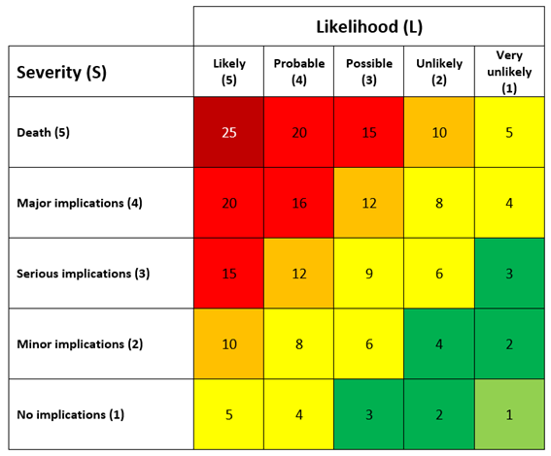

Hazard | Risk level before measures  (S x L = R) |  |  |  | Existing Control Measures | Athlete Health Conditions | Athlete Functional Ability | Additional Implications | Additional Measures | To be actioned by | By when: | Risk level after measures  (S x L = R)
 | S | L | R | RR |  |  |  |  |  |  |  | S | L | R | RR
What is the issue relevant to Covid-19 that needs to be considered? |  |  |  |  | What does WG guidance ask/require? | Are there any underlying health conditions? | What is the functional ability of the athlete and what equipment (if any) does the athlete use to increase functional ability? | What are the implications of the athlete’s functional ability or use of equipment regarding Covid-19 | What additional measures need to be put in to place to reduce the risk to the athlete linked to the Hazard. | Who will action the interventions? | For when?
Catching / Spreading Covid-19 | 5 | 3 | 15 |  | - Good hand hygiene  - Physical distancing (2m)  - Reduce contact with others  - Cleaning of surfaces, facility and equipment  - Temperature checks  - Aware of what to do is symptomatic
Travelling to training | 4 | 4 | 16 |  | - 5 mile travel radius  - Location of training facility to minimise travelling  - Advise against public transport
Lack of Awareness | 5 | 5 | 25 |  | - Frequent communications  - Provision of Covid-19 training for athletes & coaches

Hazard | Risk level before measures  (S x L = R) |  |  |  | Existing Control Measures | Athlete Health Conditions | Athlete Functional Ability | Additional Implications | Additional Measures | To be actioned by | By when: | Risk level after measures  (S x L = R)
 | S | L | R | RR |  |  |  |  |  |  |  | S | L | R | RR
Receiving coaching | 5 | 4 | 20 |  | - Provision of Covid-19 training for athletes & coaches  - Using PPE (?)

Risk Assessment discussed with athlete: |  | Yes / No |  |  | Athlete made aware of their responsibility? |  |  | Yes / No
 |  |  |  |  | Recommended phase of return to training: |  | Phase 1 / Phase 2
Risk Assessment Officer: |  |  |  |  | Role:
Date of Assessment: |  |  |  |  | Date of Review:

