Sunguarding

Sunburn fast becoming an unacceptable outcome of organised outdoor activity. With skin cancer the UK's No.1 cancer, and sunburn in childhood doubling the risk of melanoma, it is vital that those who work with others outdoors are educated around how to effectively provide adequate of sun protection in summer sessions.
With excessive temperatures become more common during the summer months, an understanding of heat protection will also help those who provide activity, avoid, recognise and treat heat related illnesses.
With sports requiring prolonged periods outdoors, activity leaders and coaches have a responsibility to minimise all UV related risks, as well as model good behaviour. To support this and make sun protection easy to implement, the WSA has partnered with the Melanoma Fund to provide advice and free resources that will highlight the importance of Sunguarding, helping futureproof your sessions, keeping everyone sun safe.

Sun protection
- Sun policy: Creating a policy around sun and heat protection will ensure others know your rules and that you take this matter seriously. It will also ensure that you are being met half way by parents. Keep this simple and easy to follow and targeted to y our audience and activity.
- UV Index: This is a great way, non-negotiable way to check if sun protection is required, even on overcast days and can be found on your mobile under the weather app. If the forecast promotes a level of 3+ the sun is strong enough to cause sunburn, and sun protection is required.
- Leading by example: Improving your own sun protection attitude and habits provides a stronger message than instruction alone. Applying and reapplying sunscreen in view of others whilst advising others to do so – whatever the age - is an effective way to inspire healthy behaviour.
- Utilising shade: Shade should be the first line in defence when it comes to sun protection. Simple measures such creating shaded spots for lunch breaks, spectating and when coaching tactics, can be highly effective. Use gazebos, umbrellas or shade from trees, especially during the four hour window around noon when the sun it most powerful.
- Healthy attitude: The importance of sun protection can underestimated, especially if this is not a regular habit, or if it was not seeded in your own childhood. Sunburn however is far becoming unacceptable, and seen as a failure around duty of care from your peers and parents. Providing effective provision will ensure your reputation around good practice is protected.
- Marginal gains: A good way of inspiring sun protection is to promote the fact that sunburn is not only painful unsightly and dangerous, it will disrupt enjoyment and optimal performance, whatever the activity. If you have a multiple day event, getting sunburn on the first day can compromise the rest.

Heat protection
Implementing the following strategies can reduce the risk of heat-related illnesses and provide a ensure a safer environment for all during summer sessions:
- Scheduling: Keep an eye on weather forecasts to avoid organising sessions during peak heat times or heat waves. If unavoidable, plan activity early in the morning or later in the evening, a time when temperatures are typically lower.
- Hydration: Organise hydration breaks, every 15-20 minutes, especially during intense activities. Advise participates to drink plain water before practice starts and avoid caffeinated or sugary drinks.
- Cooling Stations: Where possible, set up cooling stations with fans, misters, or ice towels to help participants cool down quickly. Limit the duration of practice sessions to avoid prolonged exposure to heat.
- Lower Intensity: Reduce the intensity of workouts, especially during the hottest parts of the day, and include more rest periods. Keep a close eye on anyone who is struggling – always put safety first.
- Education: Ensure everyone in your care fully understands how to avoid heat-related illnesses, and recognise the signs. This includes heat exhaustion and heat stroke, such as dizziness, headache, nausea, confusion, and excessive sweating or lack thereof.
- Emergency Procedures: Have a clear plan in place for responding to heat-related emergencies, including knowing when and how to seek medical assistance.
Melanoma Fund resources
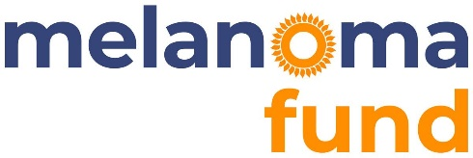
The following resources are freely available, helping you navigate all the about actions:

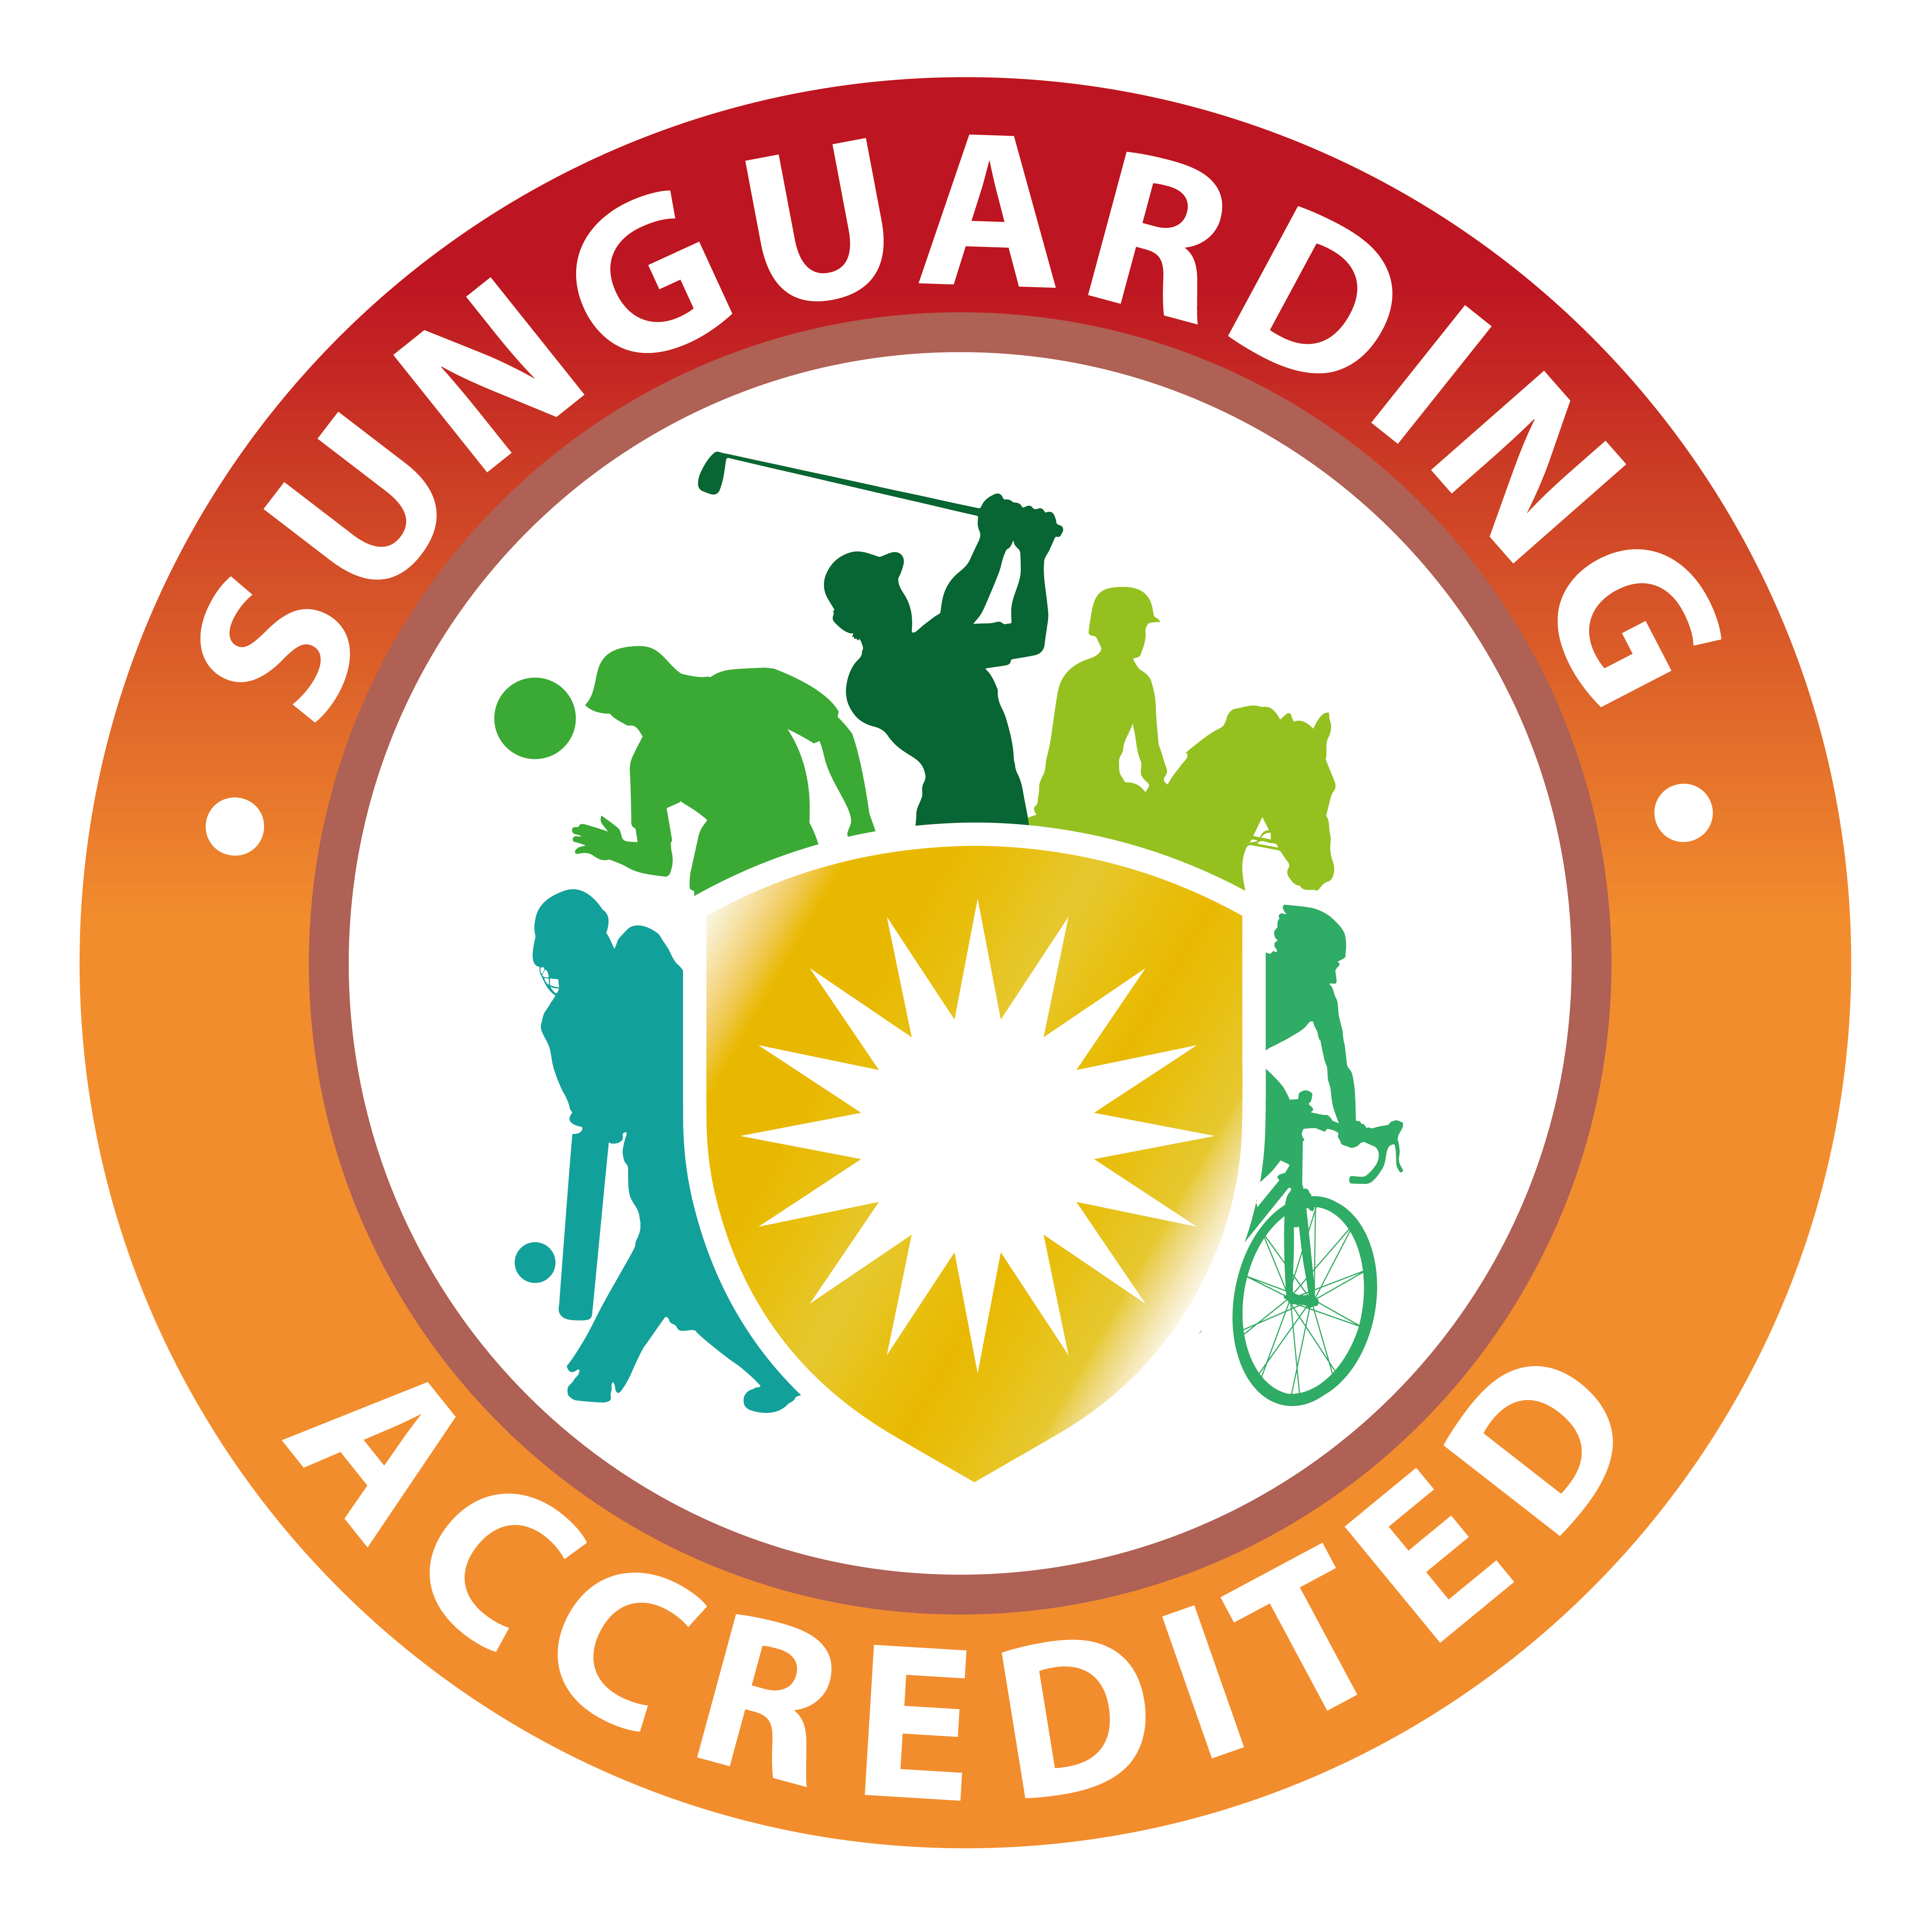
Sunguarding: Sun and heat protection course for sports and outdoor recreation:
If you work in sports or outdoor recreation updating your skills is a vital part of your responsibility, and that includes your understanding of sun and heat protection. This new Sunguarding course, provides learners with certificated accreditation, 3 CPD points and the knowledge required to mitigate all types UV risks including:

- Effective sun protection
- Awareness of skin cancer
- Heat protection
- Leading by example
For further information visit: https://melanoma-fund.co.uk/sun-and-heat-protection-course/

Outdoor Kids Sun Safety Code
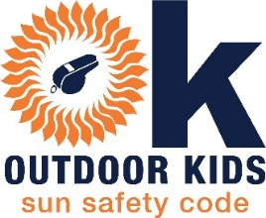
When working with KS2 children outdoors, it is the responsibility of those who lead to ensure they are safe from harm, and that includes from the risk of UV exposure. To make this effective, your actions need to be consistent and aligned within your organisation. By becoming OK Accredited, you will receive a toolkit designed to create awareness and educate not only adults but also the children taking part in activity. For further information visit: https://melanoma-fund.co.uk/ok-sun-safety-code/

Sunguarding Outdoors
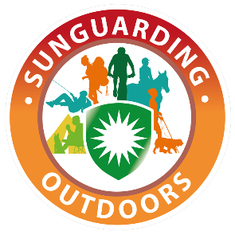
Being active outdoors is important for our health and wellness, as is being adequately sun protected. It can be easy to forget this when organising activity with so many other health and safety factors on the table, so Sunguarding Outdoors is designed to make it easy. Designed for outdoor individuals, groups, and clubs, thw advice is simple and will help keep everyone sun protected, at the right time and place.
For further information visit: https://melanoma-fund.co.uk/sunguarding-outdoors/

Sunguarding Sport
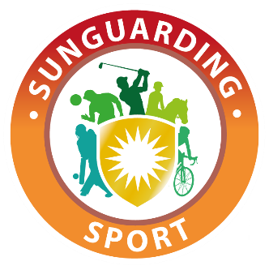
Sunguarding Sport is a campaign for individuals, groups, and clubs, to help keep everyone in competitive sport sun safe. The campaign provides specific tips and advice as well as a toolkit of resources that can be shared both digitally and in print, underpinning your rules and regulations around sun and heat protection.
For further information visit: https://melanoma-fund.co.uk/sunguarding-sport/

