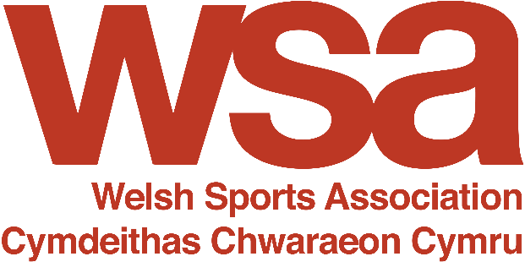

Welsh Language Policy – Polisi Iaith Gymraeg

Introduction

  - We acknowledge the fact that, under the Welsh Language (Wales) Measure, 2011, the Welsh language has official status, and should be treated no less favourably than the English language.

  - We believe that it is good business practice to provide services in the language of choice of our customers. We also believe that it shows respect to our workforce to encourage and facilitate the use of their chosen language in the workplace.

  - We will ensure that we make constant progress towards achieving this ambition, and this Welsh Language Policy sets out our current commitments in relation to using Welsh and also, where appropriate, sets targets to help us develop our use of Welsh.

  - The scope of our commitments in this policy should be interpreted reasonably – they are limited to activities and services in Wales, or which are delivered to people living in Wales, and also limited to activities and services which we are able to control or influence. They are also limited to the extent of our available resources – both human and financial, though we will always meet our legal responsibilities in a positive manner.

  - Please direct any comments or complaints about this policy to the Chief Executive, or Chair, of WSA. Our contact details may be found on our website.

Public Image

Signs

  - We currently do not have any permanent or temporary signs. We do not anticipate developing any in the foreseeable future, but if we do, they shall be bilingual, where appropriate.

Corporate Brand

  - Our corporate brand is bilingual.

Stationery

  - Our stationery bears our bilingual corporate brand.

Business Cards

  - Our business cards are bilingual.

Website

  - Our website includes some Welsh. We will use more Welsh on our website as and when resources permit.

Digital Services

  - The DBS service delivered to the sector by Vibrant Nation, our subsidiary company, is delivered in English and Welsh. We boast a bilingual helpline and DBS system – the only Welsh/English bilingual system on the market, in the UK.

Social Media

  - We aim to translate scheduled posts and announcements where resources allow. We will always reply to queries in the language they are asked in a timely manner.

Broadcast Advertising

  - We currently do not use broadcast advertising. We do not anticipate doing so in the foreseeable future but, if we do, it shall be bilingual, where appropriate, budgets permitting

Press Advertising

  - We currently do not advertise in the Welsh press. We do not anticipate doing so in the foreseeable future but, if we do it, shall be bilingual, where appropriate, budgets permitting.

Recruitment advertising

  - We will advertise bilingually. If Welsh is required within a role, an interview in Welsh will be offered.

Outdoor Advertising

  - We currently have a small number of banners for indoor/outdoor use. These are bilingual. We currently do not have any other outdoor advertisements. We do not anticipate developing any in the foreseeable future but, if we do, they shall be bilingual, where appropriate, budgets permitting.

Supporting our members
  - We will work with relevant organisations to provide Welsh-language courses for our members, preferably at a discounted rate for Members, where possible.

Printed Publications

  - All external printed publications shall be bilingual, where appropriate, budgets permitting.
Electronic Publications

  - All electronic publications shall be bilingual, where appropriate, budgets permitting.

Exhibition and Marketing Materials

  - All appropriate materials will be produced bilingually, where appropriate, budgets permitting.

Pre-recorded Messages and Audio Announcements

  - The telephone answering service for the DBS helpline is bilingual. All office landlines will have a bilingual answering message. Staff are encouraged to use bilingual pre-recorded messages on their mobiles.

Communications

Record Keeping

  - We currently do not record or track the language choice of any business contacts. We will record and track the language choice of our business and customer contacts when resource permit.

Face to Face Communication

  - We cannot guarantee a Welsh language service, but we welcome the use of Welsh by staff able to do so.

Answering telephone calls

- We currently answer calls in English only. When, in the future, we have staff able to converse in Welsh, the policy will be amended.

Written Correspondence (Paper and Electronic)

- Currently, we predominantly write to people in English, however some written correspondence is also communicated in Welsh. We acknowledge our customers’ freedom to correspond with us in Welsh and we will respond in their preferred language whenever it is practically possible and our resources permit.

- We will encourage bilingual staff able to write in Welsh to use a Working Welsh logo on their correspondence.

- We will consider bilingualism when sending and receiving correspondence, based on the nature and purpose of the correspondence, subject to the availability of resource.

Forms and Account documents

- Our forms and account documents are in English only, based on the software that the organisation currently uses.

Staff and the Workplace

Annual Budget

- Translation services will always be considered by the Board when setting the annual budget and in years when profit is forecast, the Board must use best endeavours to ensure that the budget for translation services meets the expectations of our members.

Assessing Language Skills Requirements when Recruiting

- We will record what level of Welsh language skills are required to perform certain positions within the organisation e.g., our bilingual DBS Service. However, as a minimum every job-advert will promote Welsh language as desirable.

Recording and Developing our Staff’s Language Skills

- We keep a record of the Welsh language skills of our employees and support any employee who wishes to access Welsh as a CPD opportunity.

Internal Communication

- We expect staff to respect the linguistic preferences of their colleagues and customers. We will support and facilitate the use of Welsh and English in the workplace.

Internal Publications

- Our newsletter is currently in English only. We will ensure that it is bilingual as and when our resources permit, furthermore, our newsletter mainly compiles of electronic links to other news. If these links are available bi-lingually, they will be included. As a minimum, we use our bilingual brand logo.

Welsh language software

- We allow our staff to install a Welsh language interface for any software they use which has one available.

Leadership

- We will ensure that this policy is supported at the highest level in our organisation. Our Chief Executive is responsible for implementing, championing and reviewing this policy.

Awareness

- This policy will be provided to all of our staff.

Review

- We will assess and revise this policy at least every two years.

Services delivered on our behalf

- We will encourage every contractor or third party that delivers services on our behalf to comply with this policy.

Last reviewed March 2023. Next review date March 2025.

