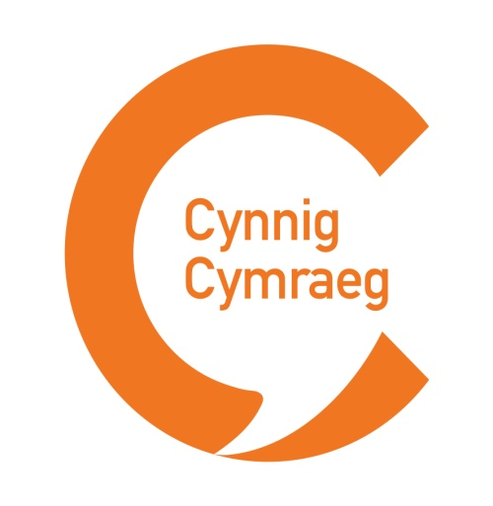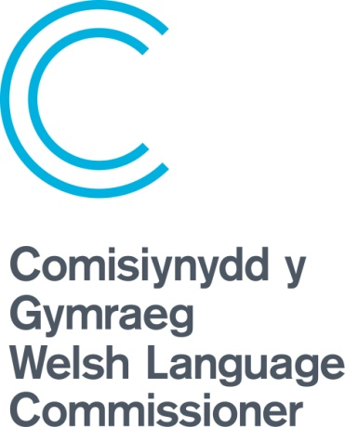
What is Cynnig Cymraeg?
The aim of Cynnig Cymraeg (Welsh offer) is to let the public know about the Welsh language services you offer, and encourage everyone to use them.
If you are a charity or a business that already has a Welsh language policy in place or you’re looking to draw one up, this is an excellent opportunity to work with the Welsh Language Commissioner to ensure that your policy is fit for purpose to receive recognition and to increase the use of your services.
Evidence shows that 86% of the population feel that that Welsh language is something to be proud of. 94% of fluent Welsh speakers feel that having a good Welsh language service helps a company to stand out. It will also demonstrate to public sector fund bodies that you are meeting their expectations with regards to the Welsh language.
Find out how you can receive the logo which demonstrates your positive approach to the Welsh language. As recognition from the Commissioner, you will receive of the Cynnig Cymraeg logo, templates and ideas for promoting your services. Through regular discussions we will work with you to ensure that your services continue to develop and that we can track the increase in usage.
How can you be part of Cynnig Cymraeg?
For the scheme to work, the Commissioner has to be confident that your Cynnig Cymraeg is an accurate reflection of what’s available. The Commissioner’s specialist Hybu team will support you through each step of the process:
- Assess your organisation’s current Welsh language use
- Prepare a development plan outlining how you can maintain, and strengthen your Welsh language provision
- Identify the highlights of your Welsh offer, those that you want customers to know about – this will be your Cynnig Cymraeg
- Raise awareness of your Cynnig Cymraeg amongst your customers and staff.
We’re keen that everyone who’s part of the scheme assesses the impact of their Cynnig by collecting information about the current use of Welsh language services, and collect feedback from customers and service users. The Hybu team can offer ideas on how to do this.
If you already have a Welsh language policy, share it with the Hybu team who can advise you on how to update it, and adapt it to the Cynnig Cymraeg.

How can we help you?
The Hybu team will help you through the process. We work with organisations of all kinds, those who are starting out, and those who already offer everything bilingually.
Once you’ve got a robust Welsh language policy in place, it will be give approval from the Commissioner, and you’ll be able to use the Cynnig Cymraeg logo. We’ll share it with you electronically so you can include it on your website, social media profiles and print materials.
To recognise your good work, we’ll publish who is part of the Cynnig Cymraeg on our website, and share that information with funders, when relevant.
Here are some ideas on how to put together a clear and appealing Cynnig Cymraeg:
The aim of publishing your Cynnig Cymraeg is to let people know what you can offer. It’s your Cynnig Cymraeg so use your organisation’s style and tone of voice.
Start your Cynnig Cymraeg with a brief statement on the value your company places on the Welsh language. You should note that your Cynnig builds upon a more detailed Welsh language plan.
Follow this with a series of short, punchy bullet points. This is your opportunity to celebrate your Welsh language provision, even if you can’t offer everything in Welsh at the moment.
Be clear and concise. Avoid sentences that contain “where possible” and “on request”.
The Cynnig Cymraeg should encourage the use of your Welsh services, so use positive language:
- “Speak to us in Welsh over the phone”
- “Speak Welsh when you see the Iaith Gwaith badge”
- “Get in touch if you’d like a Welsh speaker to visit your school”
- “Our website is bilingual”
- “You can use Welsh at our ATMs”
If you have lots to include in your Cynnig Cymraeg, you could combine points, e.g.
- “Contact us in Welsh over the phone, by letter or email”
- “Read all our publications in Welsh”
Your Cynnig Cymraeg should help inform your staff and volunteers as well as your customers or service users. So think about both:
- What can customers expect from you?
- What are you offering to your staff or volunteers?

The Cynnig Cymraeg is not available to organisations who work directly under Welsh Language Standards
Using the Welsh language – the business case (Research on the business sector, similar research available on charity sector)
More ideas / toolkit on how to use the logo plus templates to follow.

