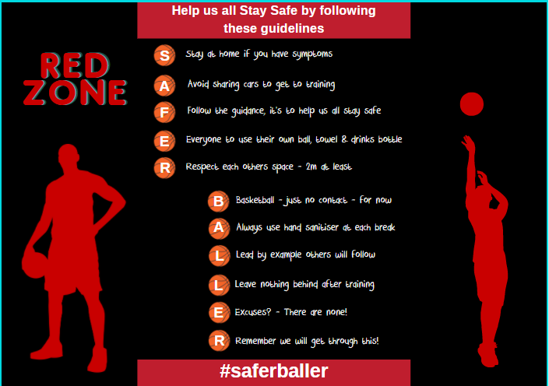
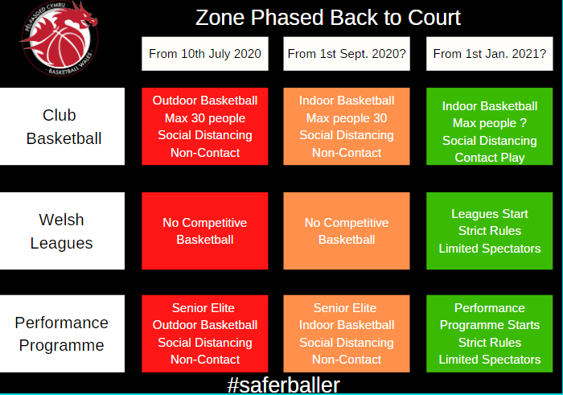
RED ZONE
Risk Assessment Date: 12th August 2020
Review Date: 1st September 2020 & monthly thereafter
BASKETBALL WALES COVID-19 CLUB RISK ASSESSMENT
HAZARD – Health Risk of Infection due to COVID-19 Global Pandemic

AREA/ACTIVITY | WHO MIGHT BE HARMED | CONTROL MEASURES | ADDITIONAL CONTROLS | ACTION BY WHO? | ACTION BY WHEN? | COMPLETED
Vulnerable Groups  RED ZONE | People with underlying health conditions identified as high risk | All Club members, coaches, volunteers & support staff should be made aware of the greater risk of contracting Coronavirus for people with underlying health conditions & those from a BAME background. | Club Covid-19 Officer to ensure information is accessible to suit individual needs.
Pre-Attendance Check | Players, Coaches, Volunteers & Support Staff | All Clubs must set up a booking system where players can make their self-declaration on their Covid-19 status. Participants must agree to the statement to be able to book onto the session. This can be done in a variety of ways including verbally by phone or as a checkbox on a web form. Parents/Guardians for participants under 18 must indicate on behalf of their child. | Clubs are advised to use the prepared statement in the Basketball Wales Club Protocols Pack.
Screening at Basketball Sessions  RED ZONE | Players, Coaches, Volunteers & Support Staff | Clubs to set up a screening & registration procedure for all people attending sessions carried out by their agreed ‘Responsible Person’ including: -  - Taking a register of participants & other attendees present  - Ensuring self-declarations are provided  - Ensuring attendees understand the Covid-19 measures in place  - Monitoring of the session to ensure compliance with the Covid-19 measures  - Ensuring safe entry & exit measures  - Dealing with non-compliant people | Follow any venue specific procedures.  Use the Basketball Wales Self-Declaration Poster.  Advise people unable to agree the self-declaration to return home & follow Welsh Government guidance on self-isolating & obtaining a test.  Documentation must be kept for 2 years.
AREA OR  ACTIVITY | WHO MIGHT BE HARMED | CONTROL MEASURES | ADDITIONAL CONTROLS | ACTION BY WHO? | ACTION BY WHEN? | COMPLETED
People returning after isolation  RED ZONE | Players, Coaches, Volunteers & Support Staff | Clubs to set up procedures for managing people wanting to return to training or volunteering in the Club after having a suspected or confirmed case of Coronavirus: -  - Club member to contact Club COVID-19 Officer before they return to basketball sessions  - Club COVID-19 Officer to advise club member to see their GP for a check-up prior to returning | Coaches may need to implement a staged return for individuals.
Personal Hygiene  RED ZONE | Players, Coaches, Volunteers & Support Staff | Clubs to set up procedures & guidelines for all people attending sessions: -  - Use of hand sanitiser on entering, during & leaving the session  - Wash hands effectively after using the toilet.  - Arrive ready to train  - No sharing of towels, water bottles or snacks | Communication to Club members prior to sessions re-starting.  Reminders during sessions.
Social Distancing  RED ZONE | Players, Coaches, Volunteers & Support Staff | Clubs to ensure the current Welsh Government regulations on social distancing is maintained: -  - Follow organisers instructions on maintaining 2m distance on arrival & leaving the venue & during breaks.  - Maximum of 30 people per session including coaches, volunteers & other attendee’s  - Train & Go – no congregating after the session.  - No car sharing outside your household  - No bodily contact  - No handshakes or high fives  - No spectators within close proximity of the session unless required for medical or supervision reasons  - Spectators in general should remain away from the training area. | Follow any venue specific procedures.  Reminders during sessions.
AREA OR  ACTIVITY | WHO MIGHT BE HARMED | CONTROL MEASURES | ADDITIONAL CONTROLS | ACTION BY WHO? | ACTION BY WHEN? | COMPLETED
Equipment  RED ZONE | Players, Coaches, Volunteers & Support Staff | Coach to set up equipment needed for the session to minimise the number of people involved in handling equipment. Clubs need to put into place procedures for cleaning of equipment: -  - Any equipment used must be cleaned & sanitised after the session including club balls, cones, floor markers etc.  - Check with your venue on any post session cleaning they may require that you carry out.  - Document cleaning carried out for each session – use the Basketball Wales Club Session Checklist | The Club Covid-19 Officer or other appointed Club Member should oversee the session, ensuring compliance with safety measures.
PPE & Cleaning  RED ZONE | Players, Coaches, Volunteers & Support Staff | Clubs need to ensure they have adequate provisions of any PPE: -  - Document the cleaning carried out for each session – use the Basketball Wales Club Session Checklist  - Face coverings should be used by coaches, volunteers & support staff  - Disposable gloves, apron & a face mask must be worn to administer First Aid & to carry out cleaning after sessions.  - Hand sanitiser should be provided for participants, coaches & volunteers. No-touch dispensers are recommended.  - Paper towels or paper roll to be used to clean up spills  - Cleaning products should meet Welsh Government guidance.  - Cleaning materials must be stored & handled in accordance with individual product guidelines  - Rubbish bags – bag all waste, tie securely & dispose as the venue procedures dictate. | Follow any venue specific procedures.  The Club Covid-19 Officer or other appointed Responsible Person should oversee the session, ensuring compliance with safety measures.
AREA OR ACTIVITY | WHO MIGHT BE HARMED | CONTROL MEASURES | ADDITIONAL CONTROLS | ACTION BY WHO? | ACTION BY WHEN? | COMPLETED
Basketballs  RED ZONE | Players, Coaches, Volunteers & Support Staff | Clubs to advise participants: -  - Bring their own ball if they can & mark it clearly with their name,  - No ball passing to others  - Participants to retrieve their own ball.  - Clean & sanitise their own ball before & after use | Reminders during sessions.
General running of the club  RED ZONE | Players, Coaches, Volunteers & Support Staff | Clubs should maintain day to day standards in areas such as safeguarding, health and safety, equity, and equality during this phased return to basketball. Clubs are advised to: -  - Maintain regular club committee meetings to ensure standards are maintained.  - Consider whether sessions with smaller group sizes (less than the maximum permitted group size) would be easier to manage initially.  - Ensure there are open & honest discussions within the club committee about the club’s ability to maintain standards.  - Seek help & advice from the Basketball Wales Lead Covid-19 Officer if required  - Take part in the Basketball Wales Covid-19 Support Hub sessions to share best practice & gain support if required.

