These notes are provided to help understand the background to risk management; the templates provided later in the document need to be amended to suit your specific needs.
Risk Management Planning
- The management of risk needs to be embedded into the day to day activities as well as the short, medium and long-term planning of the organisation.
- Identification, control and assessment of impact of any risk can be improved by using effective frameworks that allow informed decisions.
The Governance and Leadership Framework for Wales (GLFW)* refers to risk and risk management in four of the seven Principals - P1, P2, P3 & P5, the following text is from P5:
“Risk management in sport is often thought of as liability for accidents and/or financial risks. Both types of risk are important but a thorough risk management strategy should look strategically across the environment at the potential risks that exist which may stop the organisation achieving its vision, mission or purpose.
For example what are the risks that may stop your organisation growing? What are the risks that may prevent your participants from becoming elite level athletes? Do you have a risk associated with access to facilities or staff turnover?”
These are two examples from the Director Behaviours in the GLFW referring to risk:
“I ensure that I am up-to-date with the organisation’s risk register and am proactive in anticipating any potential threats to the organisation.”

“I offer or encourage creative actions to mitigate potential risks.”

Organisation’s Principles of Risk - these are essential for the development of good risk management process and practice. They are derived from the corporate governance principles as risk management is part of an organisation's internal controls. Hence the detail in P5 - STANDARDS, SYSTEMS AND CONTROLS
Individual Approach - the principles need to be adapted and adopted to suit each individual organisation. This approach to the principles needs to be agreed and set within a risk management policy, process and strategies all supported by the use of risk register(s) and issue logs.
Any Risk Management Plan must:
- acknowledge actual and potential threats or risks to the successful delivery of the strategic and operational goals;
- include planned activities to minimize or eliminate the risks;
- support business outcomes;
- manage risk in line with business needs;
- support business change – particularly important when ways of working and/or planning change and/or when there are changes in personnel (Board Directors and employees)
- ensure consistency of application of the risk management
- undergo continual improvement as circumstances change
The risk management plan needs to be capable of integration into, or co-ordination with, the annual operational plan and must be reviewed regularly.
Effective risk management is likely to improve your organisational performance by contributing to:
- fewer sudden shocks or unwelcome surprises
- more efficient use of resources
- improved service delivery to members and other stakeholders
- reduced time spent fire-fighting, more time to develop effective strategies
- potentially lower costs
- new ideas evolving during the risk analysis process
- improved likelihood of change initiatives being achieved when risk is managed
- better focus on doing the right things properly
- less time being wasted on ‘issues’
- reduced likelihood of fraudulent activity
- limiting breaches of e.g. anti-doping regulations
Risk management should be most rigorously applied where critical decisions are being made. Decisions about risk and the level of acceptable risk, will vary depending on whether the risk relates to short, medium or long term goals; some risks will always be present regardless of timeframe (see strategies for risk management later).
Short term - at operational level the emphasis is on short term goals to ensure ongoing continuity of business services; remember decisions about risk at this level must support the achievement of the long and medium term goals as well.
Medium term - these goals are usually linked to programmes of work and projects to bring about change(s). Decisions relating to medium term goals are usually narrower in scope than strategic decisions, have shorter timeframes and less financial responsibilities, although not always!
Long term - the risks associated with long term strategic decisions may not become apparent until well into the future. That's why it's essential to review these decisions and associated risks on a regular basis and not wait to “see what happens”.
There are two parts to a risk management plan:
1. The analysis of risk - which involves the identification and definition of risks, plus the evaluation of impact and consequent action. This information should be placed into a risk register.*
2. The management of risk - covers the activities involved in the planning, monitoring and controlling of actions that will reduce the identified threats and potential problems. By putting in place effective frameworks for making informed decisions that include risk management the likelihood of achieving the objectives or goals from the strategic plan is significantly improved.
The risk analysis and risk management phases must be treated separately, to ensure that decisions are made objectively and based on all the relevant information.
A major part of any risk management plan is an appropriate communication of risk information, including simple mechanisms to increase visibility of risks and making risk more widely considered.
The formal recording of information is an important element in risk analysis and risk management. The risk register provides the foundation that supports the overall management of risk, it is not the “answer to risk management” it is a tool that assists the process.
A “fit for purpose risk register”
- requires time and top-level commitment
- requires identification of individual accountability, scrutiny and challenge
- guarantees risk judgments are decided on sound information (provided that the risk assessments have been carried out by those who understand the risk associated with the work/activity)
- requires that mitigating actions or decisions must be applied throughout the organisation (can’t have one rule in one area of work and a different rule in another – seems obvious but not always adhered to in practice)
For each activity consider:
- What risks are to be managed?
- How much risk is acceptable?
- Who is responsible for the risk management activities?
- What is the relative significance of the time, cost, benefits, quality assurance, stakeholder involvement etc. in the management of the identified risks?
- Is the risk too great to be managed – so the activity should be curtailed?
How to carry out an “analysis of risk” (often referred to as risk assessment)
Risk assessments are not difficult but they take time to do properly. It pays to be sensible and spread the load as far as possible. People should carry out risk assessments in their own particular areas of responsibility such as premises, maintenance, catering, manual handling, event management, finance etc. or other specialist areas specific to the organisation.
The advantage of adopting this system is that the people carrying out the risk assessments will have detailed knowledge of the areas concerned. People are also more likely to buy into the process if they have been involved in writing the assessment rather than having it imposed on them.
The risk assessment process and resulting risk register should be co-ordinated by the person who has overall responsibility for health and safety, both are also key areas for the Board to consider and continuously monitor.
Firstly, look systematically at each area with the aim of identifying all the hazards, risks and existing safety measures to mitigate the risk e.g. policies, procedures, action plans etc. Then consider if any additional safety measures or ‘controls’ if put in place would reduce the risks further.
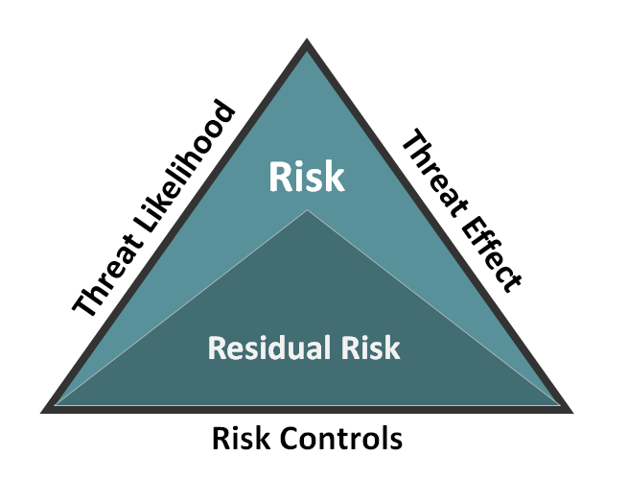
A hazard is something with the potential to cause harm and this can include substances, machines, equipment as well as methods of work or activities.
Risk is the likelihood of harm (threat likelihood) from a particular hazard occurring and the likely severity (threat effect) of the harm.
Risk controls reduce the gross risk to leave the residual risk.
Gross risk is the probability of an event or situation occurring coupled with an estimate of its impact. The potential impact should be assessed broadly by reference to the potential effect on the realisation of the organisation’s strategic plans and objectives.
Risk assessments must be carried out for any activities that your organisation undertakes both in the usual place of work and away from your usual premises such as visits, fundraising activities, away matches etc.
Prioritising Risk
Once key risks have been identified the risks must be prioritised. Initially this is done by examining the “gross risk” associated with the event or situation.

Likelihood | 5 | 5 | 10 | 15 | 20 | 25 |  | Risk Rating
 | 4 | 4 | 8 | 12 | 16 | 20 |  | High
 | 3 | 3 | 6 | 9 | 12 | 15 |  | Medium
 | 2 | 2 | 4 | 6 | 8 | 10 |  | Low
 | 1 | 1 | 2 | 3 | 4 | 5
 |  | 1 | 2 | 3 | 4 | 5
 | Severity of Outcome
A risk evaluation matrix is normally used to assess the impact of risk and the likelihood if something occurring. This allows prioritisation to reduce the most exposed areas of risk first. This example is a simple 5 x 5 matrix:

To determine the risk rating, grade both the likelihood of something happening and the severity of the outcome should the event occur.
The likelihood and severity are usually graded on a scale of 1 to 5 with one being low and five high.
Multiply these two values together to calculate the risk rating. The answer should be between 1 and 25, and the higher the number the higher the priority of the risk – so determining mitigating actions becomes more urgent.

A more detailed example is shown here from a brewery considering impact of external factors on beer production.
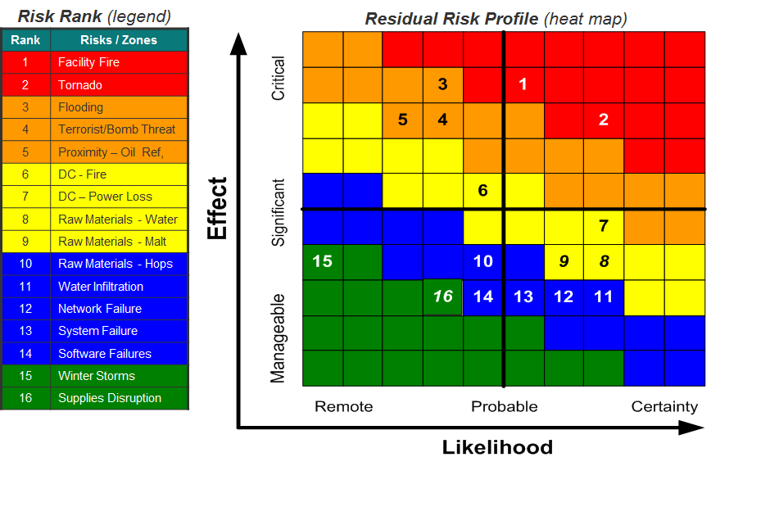

An embedded control system is vital.
Once the gross risks have been prioritised each risk needs a preferred control process for avoiding or mitigating the risk. It also needs to be established who is best placed to manage and account for each risks.
The control systems introduced should become part of the normal practices of the organisation rather than independent or additional. (Many organisations will already have mitigating actions in place to reduce risk sometimes without even realising it.)
There are a number of strategies for managing a given risk, you could:-
- accept it;
- transfer it partially or fully to another party (insurance or joint venture);
- eliminate it by adopting an exit strategy;
- controlling it through building in safeguards into your core business;
- ensure that key individuals manage it;
or a combination of the all of the above.
It is better to build appropriate mechanisms into existing procedures and information systems than to develop entirely separate risk reporting models.
Communication is an important part of successful risk management - ensure good communication between different levels of the organisation and across various roles. Good communication can help organizations identify, assess and control risks and put in place effective frameworks for making informed decisions

Guidelines to Developing a Policy and Strategy on Risk (with example templates below)
Risk management should be an integral part of every organisation’s day to day functions. One of the benefits in considering Risk Management upfront is that less management time is spent firefighting problems, thus allowing concentration on strategic planning, core management functions and improving the sport/activity. Risk Management should be a framework rather than a rule book hence enabling the organisation to develop their strategy for managing approved risk levels and change them as conditions change.
As outlined above the first part of this process is to identify the risks that are significant to the fulfilment of the corporate business objectives and to implement a sound internal control system to manage these risks effectively.
Often financial risks are grouped together, a template example of Financial Risk Management* including setting a Reserves Policy can be found elsewhere on the WSA website.

*examples on the WSA website

Amend the templates as required to suit your specific needs
- Use the select all then replace all to amend the document for your NGB/organisation
- If your NGB/organisation is an unincorporated i.e. not a Company replace all reference to the Board of Directors with the name of your governing committee e.g. Executive or Management Group
- If your NGB/organisation is a charity your governing group may be the Trustees or similar

- RISK STRATEGY - example template
The insert NGB Board is clear about the organisation’s objectives, it’s longer term strategic aims and will consider all potential risks when key decisions are made.
Risk – an example definition, see previous pages of the document for more detail
Risk can be considered as the uncertainty of an outcome, within a range of exposure, arising from a combination of the impact and probability of potential events.
Identifying Risks
In determining a risk profile insert NGB will review information from people on the significant risks they face within the whole organisation including but not limited to:
- employees
- directors
- committee members
- key volunteers e.g. coaches, event stewards
- athletes
- stakeholders e.g. funding bodies and their own funding uncertainties
Insert NGB will examine the kinds of risks identified, the likelihood of them materialising and the ability to reduce their impact if they do occur. Insert NGB will bear in mind the costs and benefits of particular control measures once identified to determine appropriateness.
A robust process for identifying and evaluating risks to insert NGB is the foundation of our effective control system. Insert NGB will consider all types of risks faced whether strategic, operational, financial, external and reputational. Each risk will be given a category and an individual person will be identified to manage the risk.
Main types of risk (any of which may impact on our reputation)
- Strategic
Organisational structure, planning (strategic/corporate planning process), leadership and communications, commercial impact.
- Operational
Policy, human resources, information (adequacy for decision making), integrity of data, technology (use of technology to achieve objectives), project (planning and management procedures) and innovation.
- Financial
Budgetary, theft or fraud, investment evaluation, value for money, market forces and failure of financial systems.
- External
Infrastructure (both physical such as transport and electronic such as internet), legal and regulatory, political and partnerships.
Insert NGB will consider problems or near misses that insert NGB or other organisations have experienced recently, but insert NGB will also address the types of risk that have yet to materialise. Consideration will be given to integrity (probity) issues including ones related to fraud; a detailed fraud prevention procedure will be widely communicated and regularly reviewed.
Prioritising insert NGB Risk
Once key risks have been identified insert NGB will prioritise them, initially by examining the “gross risk” associated with each event or situation.
Gross risk – probability of an event or situation occurring coupled with an estimate of its impact. The potential impact will be assessed not only in direct financial terms but more broadly by reference to the potential effect on the realisation of insert NGB’s strategic plans and objectives.
A risk evaluation matrix will be used to assess the impact of risk and the likelihood if it occurring.
Once the gross risks have been prioritised each risk will be given a preferred control process for avoiding or mitigating the risk and an individual will be assigned to manage and account for it. The control systems introduced will become, as soon as possible, part of the normal workings of insert NGB rather than an independent strategy or additional policy document.

The Role of the Board
The Board is ultimately responsible for risk management and will continuously monitor identified risks to insert NGB. The Board will regularly (or insert set dates) receive and review up to date balanced reports on significant issues or known risks and insert NGB identified internal processes for managing risk. [Insert any delegated authority given to the CEO or any other sub-group e.g. The CEO will develop/keep up to date the Financial Risk Register on behalf of the Board and link it to insert NGB Reserves Policy/Process, providing regular updates at least quarterly.]
The Chair will encourage regular discussion of risks and control issues at Board meetings. A risk assessment will be included in the evaluation of every proposed major event or expenditure above £ insert amount.
The Board will also summarise its process for reviewing the effectiveness of its risk management strategy at least annually.

RISK MANAGEMENT POLICY – amend template and personalise
Purpose of this document
- The policy forms part of the insert NGB’s internal control and governance arrangements.
- The policy explains insert NGB’s underlying approach to risk management, outlines the roles and responsibilities of the Board, Committees, employees and other key parties. It also sets key aspects of the risk management process and identifies the main reporting procedures.
- In addition, it describes the process the Board will use to evaluate the effectiveness of insert NGB’s internal control procedures.
Underlying approach to risk management
- The following key principles outline insert NGB’s approach to risk management and internal control:
- insert NGB Board has responsibility for overseeing risk management within the insert NGB as a whole
- an open and receptive approach to solving risk problems is adopted by the Board
- staff and key volunteers support, advise and implement policies approved by the Board
- insert NGB makes conservative and prudent recognition and disclosure of the financial and non-financial implications of risks
- key risks will be identified and closely monitored on a regular basis
Role of the Board
- The Board has a fundamental role to play in the management of risk. Its role is to:
  - Set the tone and influence the culture of risk management within insert NGB. This includes:
    - Communicating insert NGB’s approach to risk
    - Determining what types of risk are acceptable and which are not
    - Setting the standards and expectations of employees with respect to conduct and probity
  - Determine the appropriate risk appetite or level of exposure for insert NGB
  - Approve major decisions affecting insert NGB’s risk profile or exposure
  - Identify risks and monitor the management of fundamental risks to reduce the likelihood of unwelcome surprises
  - Satisfy itself that the less fundamental risks are being actively managed, with the appropriate controls in place and working effectively
  - Annually review insert NGB’s approach to risk management and approve changes or improvements to key elements of its processes and procedures
Role of Key Employees and Volunteers
- Roles of key employees and volunteers are to:
  - Implement policies on risk management and internal control
  - Identify and evaluate the fundamental risks faced by insert NGB for consideration by the Board
  - Provide adequate information in a timely manner to the Board and its sub-committees on the status of risks and controls
  - Undertake an annual review of effectiveness of the system of internal control and provide a report to the Board
Risk management as part of the system of internal control
- Insert NGB’s system of internal control incorporates risk management. This system encompasses a number of elements that together facilitate an effective and efficient operation, enabling insert NGB to respond to a variety of operational, financial and commercial risks. These elements include:
  - Policies and procedures.
Attached to fundamental risks are a series of policies that underpin the internal control process. The policies are set by the Board and implemented and communicated to employees and key volunteers. Written procedures support the policies.
  - Reporting.
Comprehensive reporting is designed to monitor key risks and their controls. Decisions to rectify problems and reviews of potential issues are undertaken at regular meetings of the Board.
  - Business planning and budgeting.
The business planning and budgeting process is used to set objectives, agree action plans and allocate resources. Progress towards meeting business plan objectives is monitored regularly.
  - Self-Assurance Process
The annual self-assurance process is one of the ways by which Sport Wales assesses whether we are fit to receive public funds. The process assists in providing assurance that our structures, plans, policies and procedures are constantly monitored and improved so as to achieve our objectives and manage our funds effectively.
  - External audits and Third party reports.
External audit provides feedback to the Board on the operation of the internal controls reviewed as part of the annual audit. (Amend as appropriate)
From time to time, the use of external assistance may be necessary in areas such as health and safety and human resources. The use of specialist third parties for consulting and reporting can increase the reliability of the internal control system.
  - Governance and Leadership Framework for Wales (GLFW)
Signing up to and working through the GLFW seven Principals paying particular attention to risk.
  - Risk Management Process.
Insert NGB operates a risk management process/framework as follows:
    - A review/appraisal of the previous year’s risk management report
    - A ‘risk identification’ exercise for the year ahead
    - Evaluation of identified risks using risk assessments
    - Consideration of risk associated with decisions of the Board
    - Manage risks through application of risk management techniques
    - Record and monitor risks using risk registers
    - Assigning responsibility for risks to appropriate personnel.
N.B. Risk identification is not an annual process. Board/Committee’s/employees members/volunteers are encouraged to report and update risk registers and carry out assessments throughout the year.

Annual review of effectiveness
- The Board is responsible for reviewing the effectiveness of internal control of insert NGB, based on information provided by the senior employees/volunteers. Its approach is outlined below.
- For each fundamental risk identified, the Board will:
- review the previous year and examine insert NGB’s track record on risk management and internal control
- Consider the internal and external risk profile of the coming year and consider if current internal control arrangements are likely to be effective.
- In making its decision the Board will consider the following aspects.
- Control environment:
- insert NGB’s objectives and its financial and non-financial targets
- organisational structure and calibre of the staff/key volunteers
- culture, approach and resources with respect to the management of risk
- delegation of authority
- reporting to members ( and public reporting if appropriate)
- On-going identification and evaluation of fundamental risks:
- timely identification and assessment of fundamental risks
- prioritisation of risks and the allocation of resources to address areas of high exposure
- Information and communication:
- quality and timelines of information on fundamental risks
- time it takes for control breakdowns to be recognised or new risks to be identified
- Monitoring and corrective action:
- ability of insert NGB to learn from its problems
- commitment and speed with which corrective actions are implemented
- The delegated member of staff responsible for risk management will collate and prepare a report reviewing the effectiveness of the internal control system annually for consideration by the Board. (usually CEO or lead officer)

Make sure that you have a Business Continuity Plan associated with the risk assessments/register. This will be more related to major problems e.g. fire, flood, loss of key venue or personnel etc. Look at the main critical functions against these major emergencies or threats.

